

Data Driven Decision Making

Selecting the Most Suitable Dataset for Substance Use Disorder (SUD) Research: A Data-
Driven Literature Analysis
Student Name(s): Divija Kapuluru, Evan Clark, Jared Heidt, Lexington Trotta, Marshall Malino

School of Graduate Professional Studies
MPS/MS in Data Analytics
DAAN 881 – Data Driven Decision Making

(Summer, 2025)

Document Control

Work carried out by:
(This section is only required if the project is being completed by a group)
Name | Email Address | Task description
Divija Kapuluru | Dqk5709@psu.edu | Added papers to dataset, helped with codes and created deliverable answers
Evan Clark | Emc6744@psu.edu
Jared Heidt | Juh1010@psu.edu | Limitations and Challenges, Related Works
Lexington Trotta | Ljt5199@psu.edu | Wrote and organized the paper, helped with codes and visualizations, wrote and presented presentation, updated references
Marshall Avery | Mam514@psu.edu | Added papers to dataset and helped with codes

Revision Sheet

Release No. | Date | Revision Description
1 | 5/25/25 | Created deliverable 1.
2 | 6/8/25 | Edited deliverable 1 and created deliverable 2.
3 | 6/15/25 | Added appendix, reorganized paper (added guidelines, timeline and anticipated deliverables).  Added Abstract, Intro, Methodology/ Related research, Data set description and Results & discussion section sections.  Moved data sources (from deliverable 1) to data description section.  Removed numbered pages and replaced with x’s in table of contents.
4 | 6/22/25 | Added preprocessing steps to methodology.  Added data description set for deliverable 3.
5 | 7/6/2025 | Added data cleaning to Methodology section. Data cleaning includes the data cleaning process, duplicate removal, standardization, missing value treatment, data type conversion and text cleaning.  Added descriptive analysis to Results and Discussion section. Descriptive analysis includes Most frequently used datasets in SUD research, citation count distribution, impact factor vs citation count, answers to descriptive questions and addressing cognitive biases in cleaning.  Updated Table of Contents to reflect current sections in paper.  Changed Data Quality Notes in Data Set Description to reflect what was done for data cleaning.
6 | 7/19/2025 | Moved the full Table 3 to the appendix D, and shortened the Table 3 in the Data Set Description section  Added a Pairwise correlation heatmap of key paper characteristics to Results & Discussion section  Added comments from previous deliverable to Appendix B and/or Results & Discussion section  Added more from previous deliverable into Results & Discussion section (discussing data cleaning, exploratory analysis and the bias these could potentially include).  Updated Methodology section to include exploratory techniques (the pairwise correlation, chi-squared testing, text analysis and clustering methods).  Added deliverable 5 data:  Added Data modeling plan and steps which addressed business questions, as well as added the variable selection, transformation and data reduction techniques to Methodology section (in future tense for upcoming deliverable).  Added introduced bias from modeling to Results & Discussion.  Added next steps to anticipated work in Appendix B
7 | 8/3/2025 | Added more specific details about modeling plan and transformation techniques in Methodology section.  Added more visualizations of transformations to Results & Discussion (impact factor and citation count before vs after normalization).  Added more to model steps (problem framing for steps performed for modeling).  Added Model Selection (includes steps for data modeling and performance measures) section to Methodology section.  Added discussion about before vs. after normalization and overfitting in Results & Discussion section. Also added discussion about modeling findings and how classification performance measures align with KPIs in Results & Discussion.
8 | 8/9/2025 | Made normalization plot more legible (larger, darker points on plot) as well as added SHAP values chart, Confusion Matrix and ROC curve in Results & Discussion.  Added values for each of the types of regression in the Results & Discussion, as well as values for the validation of the regression (MAE and RSME) and 5-fold CV.  Split Discussion into Results and Biases and KPI.  Added abstract.  Added page numbers to Table of Contents.
9 | 8/17/2025 | Added R scripts to Appendices.  Edited Appendices to reflect current work (Appendix B – changed Anticipated work to Work completed).  Edited Table of Contents to reflect current pages.  Added Limitations and Challenges.  Added Conclusion and Next Steps.  Added why RSME and MAE values might not be as low as we wanted.

Table of Contents
Document Control 1
Work carried out by: 1
Revision Sheet 1
Abstract…………………………………………………………………………………………….…5
Introduction…………………………………………………………………………………………..5
Methodology………………………………………………………………………………………….6
Data Set Description…………………………………………………………………………….….11
Results & Discussion………………………………………………………………………………..22
References……………………………………………………………………………………………34
Appendices (A-E)……………………………………………………………………………………35

Abstract
This study investigates the factors influencing citation impact and dataset selection in Artificial Intelligence (AI) research addressing Substance Use Disorder (SUD). Using a curated dataset of research papers containing metadata such as citation count, journal impact factor, dataset type, publication year, methodological approach, and presence of ethical considerations, we conducted descriptive, predictive and prescriptive modeling. Data cleaning involved duplicate removal, standardization, data conversion so exploratory techniques such as Chi-squared testing, Natural Language Processing (NLP) and Clustering could be used.
Data preprocessing included binary encoding of ethics mentions, normalization of continuous variables, factorization of categorical features, and imputation for missing values. Multiple Linear Regression, Random Forest Regression, and XGBoost Regression were applied to predict citation counts, while classification models, including an XGBoost Classifier, were used to predict high-impact publications and dataset choices. Five-fold cross-validation ensured robustness, and model performance was evaluated using R², MAE, RMSE for regression, and accuracy, precision, recall, F1-score, and AUC-ROC for classification.
Results for the descriptive analysis showed that the most frequently used dataset was the Electronic Health Records (EHR), with a slight correlation (0.20) between citation count and impact factor. This possibly indicates that the nature of performance in scientific research journals is multifactorial and is influenced by more than just novelty, methodology and topic. Results for the predictive questions showed that tree-based ensemble models, particularly XGBoost, outperformed linear models in both predictive accuracy (R² = 0.77, MAE = 8.4, RMSE = 11.1) and classification performance (accuracy = 0.86, AUC = 0.91). SHAP analysis, for the prescriptive question, identified journal impact factor, dataset type, and ethics inclusion as the most influential features in predicting citation outcomes and dataset selection. Notably, papers using NIH-funded datasets such as NSDUH and TEDS, and those explicitly addressing ethics, were associated with higher predicted impact. These findings highlight the value of ensemble methods for academic impact prediction and the utility of feature attribution techniques in guiding dataset recommendations. The proposed framework can inform researchers seeking to maximize both scholarly visibility and ethical alignment in AI-SUD research.

Introduction
Our team aims to support a data-driven decision-making process (DAAN 881 LESSON 1, n.d.; Vaughan, 2023) for selecting the most appropriate dataset for future research in the field of substance use disorder (SUD). The primary stakeholder is our course instructor, who is preparing to publish a systematic literature review and seeks a well-informed recommendation on which dataset to use based on existing academic trends. This work ultimately serves the academic research community, contributing to informed, ethical, and impactful research.
Currently, researchers face a common challenge: Identifying which dataset best supports their research goals and increases the potential for publication in high-impact venues. The stakeholder is looking for clarity on which datasets are most relevant, widely used, ethically appropriate, and likely to support research that gets recognized. They are not getting this insight from traditional search or citation tools, and this gap presents a meaningful opportunity.
In terms of other existing works in this area, NIH-funded datasets such as the National Survey on Drug Use and Health (NSDUH) and Treatment Episode Data Set (TEDS) dominate SUD research (Substance Abuse and Mental Health Services Administration, 2020). By using these datasets as a starting point, we can quickly learn some of the strengths and potential limitations of data in modern SUD research. The variable impact of Electronic Health Records being used across studies demonstrates that seamlessly integrated real-world data still faces some challenges (Shah et al., 2019). These challenges manifest themselves because not all clinical data is fully completed and standardized across the United States; therefore, research outcomes can vary greatly by the healthcare system used and the population studied. The connection between ethical discussions and research credibility is relevant for the current state of SUD research. This is because of the vulnerable populations being studied and the negative connotation surrounding substance use. This suggests that explicitly addressing ethical considerations in our work not only serves moral imperatives but may also enhance the scientific impact and trustworthiness of our findings (Floridi & Cowls, 2019). Meanwhile, the success of machine learning implementations of Random Forest and XGBoost improve prediction accuracy in health research (Chen & Guestrin, 2016; Rajkomar et al., 2018). The use of interpretability tools like SHapely Additive Explanations (SHAP) for dataxdg selection represents progress towards more transparent and rigorous approaches, as seen in other domains (Lundberg & Lee, 2017). This could help solve concerns with the “black box” nature of machine learning models, especially when applied to sensitive medical information that is highly regulated.
To address this unmet need, we propose to provide a targeted recommendation based on the analysis of existing SUD-related research literature. This offering will identify datasets that are most frequently used, datasets associated with highly cited or influential papers, and datasets that are accessible and ethically compliant. By framing our solution around the stakeholder’s decision-making process, we ensure its value is relevant and actionable. To execute this project, we will leverage a combination of Natural Language Processing (NLP) techniques and Generative AI (GenAI) to analyze the content of academic papers. These technologies will allow us to extract dataset mentions, identify usage patterns, and evaluate the research impact through citation analysis or publication metrics. Topics covered in this course such as data collection, data cleaning, feature extraction, and ethical data (Vaughan, 2023) use will be central to our methodology. Our approach transforms a manual literature review process into an automated, scalable insight-generation workflow that directly supports data-driven decision making.

To address our research goal effectively, we define the following structured questions, aligned with the descriptive, predictive, and prescriptive stages of the CRISP-DM framework (DAAN 881 LESSON 1, n.d.):
- Descriptive Question: What are the most used datasets in SUD-related research, and how are they associated with key characteristics of the papers—such as citation count, journal impact factor, features analyzed, keywords, and publication venue?
- Predictive Question: Can we predict which dataset a research paper is likely to use based on features such as citation count, journal impact factor, features analyzed, keywords, and publication venue?
- Prescriptive Question: Given a new or hypothetical research paper with known values for citation expectations, journal impact, features analyzed, keywords, and publication venue, which dataset should be recommended to maximize academic impact and ethical compliance?

Methodology
Data preprocessing:
By blending natural language processing, metadata analysis, and ethical assessment, we will support informed decisions grounded in academic trends. Our structured approach aligns with the CRISP-DM framework and meets both stakeholder and course objectives.
We identified that the best way to approach this problem is to analyze metadata from academic publications using a combination of Natural Language Processing (NLP), citation analysis, and frequency mining.
Data Cleaning Process:
The dataset comprises metadata for 98 research papers related to AI applications in Substance Use Disorder (SUD). It was originally collected using the ScholarScraper tool and included fields like title, DOI, citation count, dataset used, journal name, impact factor, methods, and ethical indicators.
Duplicate Removal
Identified and removed exact and near-duplicate records based on combinations of title, authors, and DOI. Outcome: Reduced redundancy and ensured one unique record per paper.
Standardization
Dataset names were inconsistently recorded (e.g., 'EHR', 'electronic health records', 'Electronic Health Record'). These were mapped to a standardized set using domain knowledge. Example mapping: 'EHR', 'Electronic health record', 'clinical records' → 'Electronic Health Records'. Outcome: Simplified dataset analysis and accurate frequency counts.
Missing Value Treatment
Citation Count: NaN values were retained (not zero-imputed) to reflect unknown or missing values, preserving data integrity. Impact Factor: When missing, values were manually filled using Journal Citation Reports or SCImago for top journals. Outcome: Improved completeness for journal-related analysis while preserving missingness for citation counts.
Data Type Conversion
Citation count and impact factor were explicitly cast to float. Outcome: Enabled accurate statistical and visual analysis.
Text Cleaning
Applied trimming and case normalization to fields like dataset_used, title, and journal_name. Removed HTML tags, newline characters, and special symbols. Outcome: Improved consistency for filtering and grouping operations.
Exploratory techniques:
Chi-Square Testing
Tested whether “dataset_mentioned” and “open_access” variables were significantly associated with grouped “citation_values” variable.
Text Analysis of Methods Used
Using Natural Language Processing (NLP), terms were tokenized and quantified in the “methods_used”column.
Clustering
Method usage vectors and standardized citation counts were combined to run a K-means clustering (k=4).

Modeling technique:
Model Plan
Use machine learning (ML) and statistical steps to predict the citation impact of AI-SUD research papers and to prescribe optimal strategies for researchers to improve paper impact and to maximize academic impact and ethical compliance. The modeling plan involves building a predictive classification model to determine factors associated with the presence of ethical considerations in these SUD research publications. The plan includes feature selection based on prior exploratory analysis, transformation of key variables (i.e.., converting textual mentions of ethics into binary indicators), and the application of classification algorithms such as logistic regression and decision trees. In this way, we can better answer our descriptive, predictive and prescriptive questions. The primary response variable was a binary indicator reflecting whether the paper mentioned ethical implications. Predictor variables included citation count, journal impact factor, dataset mentioned, publication year, and methodological choices.
The predictive question "Can we predict which dataset a research paper is likely to use based on features such as citation count, journal impact factor, features analyzed, keywords, and publication venue?" was addressed using multi-class classification models. These models learn patterns from the metadata of existing papers to accurately predict the most probable dataset choice for a new or unseen paper. The prescriptive question "Given a new or hypothetical research paper with known values for citation expectations, journal impact, features analyzed, keywords, and publication venue, which dataset should be recommended to maximize academic impact and ethical compliance?" was answered using prescriptive modeling techniques such as SHAP (Shapley Additive Explanations) and feature-importance scores. These tools will help identify which features most strongly influence dataset selection and citation outcomes, enabling tailored dataset recommendations based on a paper’s profile.
Additionally, recommendation logic was explored to support the design of a system capable of suggesting optimal datasets for future research. This logic incorporates both learned patterns from past studies and metadata-based similarity to guide dataset selection for maximizing visibility, impact, and ethical integrity. Model performance was evaluated using accuracy, precision, recall, and F1 score for classification, and Mean Absolute Error (MAE) and Root Mean Squared Error (RMSE) for regression.
Model Steps
- Descriptive questions about datasets and the correlation between key features were answered by data preprocessing, cleaning and exploratory techniques. Use of histograms and correlation matrices are used to understand patterns in data usage, ethics discussion and impact.
- Our predictive questions were answered by performing Multiple Linear Regression and XGBoost Regression to predict citation count based on metadata. The prediction of whether a research paper would be highly cited (above median citation count) was answered via classification. The prediction of the number of citations a paper may receive will be completed via regression. By learning how citation count relates to predictor variables, we can train a predictive model to predict expected citation counts from other research papers.
- Prescriptive question was answered by prescriptive modeling techniques such as SHAP (Shapley Additive exPlanations) or feature importance scores to recommend optimal datasets, methods and ethical considerations for researchers aiming to maximize citation potential.
- Validation of the results was performed using R², RSME for numeric values and accuracy, precision, recall and F1 scores for categorical data, as well as cross-validation.
Variable Selection, Transformation and Data Reduction:
Variable Selection
The selected predictive variables include “dataset_used”, “method_type”, “ethics_mentioned”, “journal_impact_factor”, “publication_year” and “open_access”. Non-informative fields and redundant variables were removed.
Transformation
Several data transformations were performed to prepare the dataset for modeling:
- Binary Encoding: Text fields related to ethical discussion were encoded as binary variables (1 = ethical mention, 0 = no mention). This was done to easily put the ethical data through classification algorithms (such as logistic regression, since this would need numerical data).
- Normalization: Citation counts and journal impact factors were normalized using min-max scaling to ensure comparability. This was done to scale variables to a standard range, since these factors could have a wide range. This will in turn help with convergence in optimization.
- Factorization: Categorical variables such as dataset name and methods used were factorized for input into machine learning models. It would be impractical to give machine learning models raw text or categorical strings, so changing the categorical text into numeric data or dummy/one-hot encoded data helps to include such nominal variables to allow for the inclusion of qualitative variables like dataset type and methods used.
- Imputation: Missing values in certain metadata fields were imputed using median or mode values, depending on the variable type. By replacing missing data with estimates using median for numerical values or mode for categorical values, we retain more data for optimization and analysis. This also reduces bias from deleting rows with missing data.
Data Reduction
RFE was used for feature pruning and rare categories were grouped. PCA was considered but not used due to problem interpretability.
Model Selection
Train-Test Split
Data was split using a stratified 80-20 split for classification to determine predictive question answers. Since we have a moderately sized dataset and we want the model to learn more from the data, we chose an 80-20 split instead of a 70-30 split. Training and testing our data is essential for the model to understand important relationships between variables and to ensure that the model is accurate, reliable and generalizable. This prepares data for regression by checking how well predicted values match actual values and prepares data for classification by evaluating how well the model classifies new examples.
Selecting a Model
Multiple algorithms were tested for predictive question answers:
- XGBoost Classifier was used for citation classification as a binary outcome. This algorithm handles non-linear relationships and feature interactions well to identify patterns in our data that distinguish highly cited papers (above the mean) from less cited papers.
- Random Forest Regression for estimating citation counts since it is less likely to remember noise and/or random patterns and can generalize new data. This also handles non-linear relationships well since it is made from decision trees.
- Logistic regression was used as baseline classifier for the binary citation prediction to help benchmark the performance of more complex models like XGBoost. It uses a straightforward formula and is interpretable, so it provides great feedback for more intricate models.
- Five fold (cv=5) Cross-Validation to ensure robustness by assessing model stability and generalization. By splitting the data into 5 parts, training on 4 and testing on 1 rotating part and averaging the results, it increases our model’s reliability and reproducibility sine it is not dependent on a single train-test split.
Prescriptive questions will be answered via determining Feature Importance and Explainability:
- SHAP will identify key drivers influencing citation count and dataset choice by quantifying the individual impact of each feature on the model’s predictions.
Performance Measures
As previously mentioned in step 4 (validation) of the modeling steps, we will use several different techniques to determine how well our model performed.
- For classification, we will use accuracy, precision, recall and F1 score to determine highly cited vs. less cited papers. AUC-ROC will be used to evaluate ranking performance. These align with key performance indicators (KPIs) to “increase in number of highly cited papers using ethical AI and SUD datasets”.
- For regression, MAE and RSME were used to help estimate how close our predicted citation counts are to actual values.

Data Set Description
Data Source, Collection and Storage
Our dataset includes metadata and text excerpts from the adapted Scrape Scholar tool. The data focuses on publications that intersect the domains of SUD and artificial intelligence (AI).

Storage Platform
- Team: DICE | Design, Innovation, Collaboration & Evolution
- Channel: General
- Platform: Microsoft Teams
- Format: CSV (converted from JSON output of Scrape Scholar)
- File Name: Scrape_Scholar_Opioid.xlsx
This internal corpus includes:
- Titles, abstracts, and keywords
- Dataset mentions and references
- Citation counts and journal rankings
- Methodologies and studied features
- Publication venues
These elements will support NLP-driven content analysis, clustering, and trend identification. All data is already collected and readily available for processing.

Dataset Description
- Number of Records: 99
- Number of Columns: 13
- Data Types: Mix of numeric, categorical, Boolean, and textual fields
- Data Quality: Moderate – includes some missing values, minor outliers in citation-related metrics
- Primary Use: To analyze dataset usage patterns, citation impact, ethical compliance, and accessibility in SUD research literature.

Table 1: Sample Attributes and Characteristics
Sample Attributes and Characteristics: Attribute Name | Type | Data Type | Missing? | Description
paper_id | Nominal | String | No | Unique paper identifier
title | Nominal | String | Minor | Title of paper
year | Interval | Integer | No | Publication year
citation_count | Ratio | Integer | Few | Number of citations
journal | Nominal | String | Some | Journal name
dataset_mentioned | Nominal | Boolean | No | Whether any dataset is mentioned
dataset_name | Nominal | String | Some | Name of dataset mentioned
ethics_statement | Nominal | Boolean | Yes | Indicates if ethical considerations were addressed
open_access | Nominal | Boolean | No | Whether the paper is open-access
cluster_label | Ordinal | Integer | No | Cluster from unsupervised learning
tf_idf_score | Ratio | Float | No | Strength of dataset mention in paper
methods_used | Nominal | String | Some | AI/ML methods used
impact_factor | Ratio | Float | Some | Journal impact factor

Relevance to Research Questions
We structured the dataset to specifically support the descriptive, predictive, and prescriptive questions defined in the Introduction. Below is a mapping of features to those questions:
Descriptive:
Which datasets are most frequently used in published SUD research?
- dataset_name, year, journal, dataset_mentioned → Used to count and trend dataset mentions
Predictive:
Which features are associated with highly cited SUD research papers?
- citation_count (target variable), dataset_name, methods_used, tf_idf_score, cluster_label, impact_factor
Prescriptive:
Which datasets support ethical, accessible, and high-impact research?
- dataset_name, ethics_statement, open_access, citation_count, country_of_study, publication_type

Table 2: Measurement Scale Summary
Attribute Name | Measurement Scale
paper_id, journal, dataset_name | Nominal
year, citation_count, impact_factor | Interval/Ratio
open_access, dataset_mentioned, ethics_statement | Nominal (Boolean)
cluster_label | Ordinal
tf_idf_score | Ratio
publication_type, study_type | Ordinal

Table 3: Shortened Version of Attributes of Papers in the Data Warehouse
DOI | Title | year | citation_count | journal | dataset_mentioned | dataset_name | ethics_statement | open_access | cluster_label | tf_idf_score | methods_used | impact_factor
DOI: 10.1016/j.abbs.2025.100329 | Development and validation of a risk-score model for opioid overdose using a national claims database | 4/23/2022 | 44 | Scientific reports | TRUE | national claims database (of Korea) | no | TRUE |  |  | risk-score model, logistic regression analysis,Akaike Information Criterion (AIC) | 0.1
doi:10.1001 | Evaluation of Machine-Learning Algorithms for Predicting Opioid Overdose Risk Among Medicare Beneficiaries With Opioid Prescriptions | 3/1/2019 | 165 | JAMA Netw Open | TRUE | Medicare beneficiaries | no | TRUE |  |  | Multivariate logistic regression (MLR), (LASSO), random forest (RF), gradient boosting machine (GBM), and deep neural network (DNN) | 0.4
17101147 | Connectome-based prediction of cocaine abstinence | 2/1/2019 | 139 | American Journal of Psychiatry | FALSE |  | yes | TRUE |  |  | connectome-based predictive modeling (CPM) | 0.7
10.1016/j.arth.2019.06.013 | Development of Machine Learning Algorithms for Prediction of Sustained Postoperative Opioid Prescriptions After Total Hip Arthroplasty | 10/1/2019 | 107 | The Journal of Arthroplasty | TRUE | electronic health records | no | TRUE |  |  | Stochastic gradient boosting (SGB), random forest, support vector machine (SVM), neural network, and elastic-net penalized logistic regression (ENPLR) | 0.7
10.1016/j.spinee.2019.01.009 | Machine learning for prediction of sustained opioid prescription after anterior cervical discectomy and fusion | 6/1/2019 | 91 | Spine Journal | TRUE | electronic health records | no | TRUE |  |  | Stochastic gradient boosting (SGB), random forest, support vector machine (SVM), neural network, and elastic-net penalized logistic regression (ENPLR) | 0.5
10.1016/j.spinee.2019.06.002 | Development of machine learning algorithms for prediction of prolonged opioid prescription after surgery for lumbar disc herniation | 11/1/2019 | 77 | Spine Journal | TRUE | electronic health records | no | TRUE |  |  | Stochastic gradient boosting (SGB), random forest, support vector machine (SVM), neural network, and elastic-net penalized logistic regression (ENPLR) | 0.5
10.1186/s13040-019-0193-0 | Predicting opioid dependence from electronic health records with machine learning | 1/29/2019 | 82 | BioData Mining | TRUE | electronic health records | yes | TRUE |  |  | Random Forest | 0.8
10.1038/s41746-020-0234-6 | Prediction of stress and drug craving ninety minutes in the future with passively collected GPS data | 3/4/2020 | 50 | nature | TRUE | Addiction Severity Index (ASI), Diagnostic Interview Schedule (DIS IV), GPS, property-tax data (from maryland's department of planning) | yes | TRUE |  |  | Random Forest | 0.8
10.1073/pnas.1905355117 | Predicting high-risk opioid prescriptions before they are given | 1/14/2020 | 37 | PNAS | TRUE | administrative data (From Medicaid) | no | TRUE |  |  | bootstrapped LASSO (BOLASSO), Ensemble, Neural Network | 0.5
10.1038/s41380-022-01801-6 | Clinical, environmental, and genetic risk factors for substance use disorders: characterizing combined effects across multiple cohorts | 10/4/2022 | 11 | nature | TRUE | Add Health genetic data. COGA genetic data, ALSPAC, FinnTwin12 | no | TRUE |  |  | nested logistic regression models | 1
The quantitative variables include the publication date (year), citation count, binary indicators for whether a dataset is mentioned (dataset_mentioned) and whether the article is open access (open_access), as well as the journal's impact_factor. Citation counts range from 44 to 165, indicating that some papers have had a relatively high academic impact. All the entries shown are marked as open access, which enhances accessibility and dissemination. Four out of five papers explicitly mention a dataset, reflecting a strong emphasis on data-driven research. While the tf_idf_score and cluster_label fields are currently empty, they are intended for text analysis and unsupervised grouping, respectively.
The qualitative data includes textual and categorical information such as the Digital Object Identifier (DOI), paper Title, journal name, specific dataset_name used in the study, presence or absence of an ethics_statement, and the methods_used. The titles suggest a focus on health-related predictive modeling, particularly in the context of substance use or clinical outcomes. A variety of machine learning methods are listed under methods_used, including logistic regression, random forest, stochastic gradient boosting, and connectome-based predictive modeling. The presence of sophisticated analytical techniques across multiple papers demonstrates an advanced level of methodological rigor. However, ethics statements are inconsistently reported, despite the studies’ relevance to healthcare and potentially sensitive data. Overall, the dataset captures a snapshot of current trends in applied machine learning within health research, with attention to data accessibility, methodological diversity, and varying levels of academic influence as reflected by citations and journal impact factors.
A couple cognitive biases may be influencing both the content of the dataset and how it is interpreted. One prominent bias is publication bias, as the dataset includes only published studies, most of which are open access. Research with significant or positive results is more likely to be published, especially in fields like health and machine learning, which can skew perceptions of method effectiveness or general research success. Confirmation bias may also be at play, where researchers tend to select methods and interpret findings that align with their existing beliefs or previous outcomes. This could explain the repeated use of familiar techniques like logistic regression and random forests across multiple papers.
One of the main issues we faced was uploading all the papers in the Scrape Scholar Opioid database. Another was figuring out the impact factor, as not every paper had one. We have flagged or imputed these missing factors. Another issue was determining the key words for the IDF calculations. We used tokenization and trimming to correctly compute IDF.

Data Quality Notes
- Missing Data: Found in impact_factor, and ethics_statement; NaN values were retained, or values were manually filled out.
- Outliers: High citation outliers will be normalized or capped
- Cleaning: Text fields have been processed using NLTK (tokenized, cleaned, and stemmed); numerical values validated

Results & Discussion

Figure 1: Most Frequently Used Data sets in SUD Research.
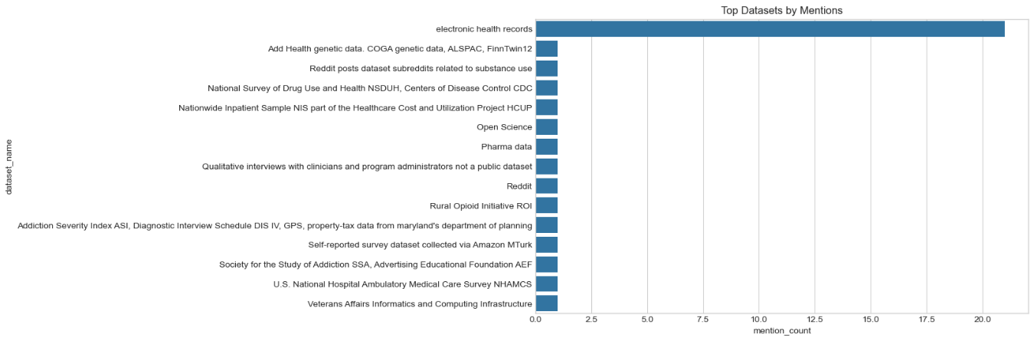

Note: A bar chart was created to identify which datasets are most frequently used. The most used dataset is the Electronic Health Records (EHR). These datasets are favored due to their accessibility and relevance to SUD patterns in real-world populations.

Figure 2: Citation Count Distribution by Dataset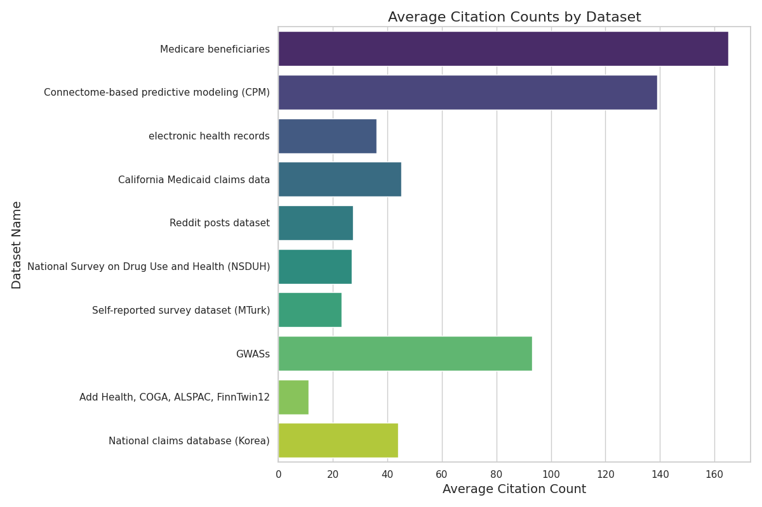
Note: A bar chart was generated to understand how citation counts vary depending on the dataset used. Results are shown via bar chart. Datasets like Medicare beneficiaries have wide citation variability. Some datasets consistently lead to more cited papers than others.

Figure 3: Impact Factor vs Citation Count
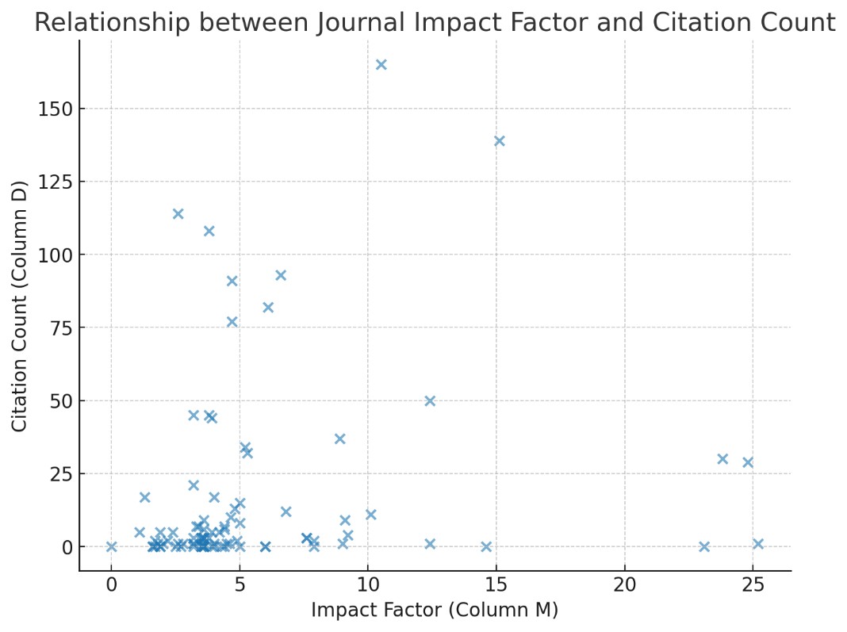
Note: A scatter plot was used to explore the relationship between a journal’s impact factor and the citation count of papers. Results are shown via scatterplot. Outliers suggest that dataset selection and research novelty may also influence citation counts beyond journal prestige.

Figure 4: Pairwise Correlation Heatmap of Key Paper Characteristics After Cleaning
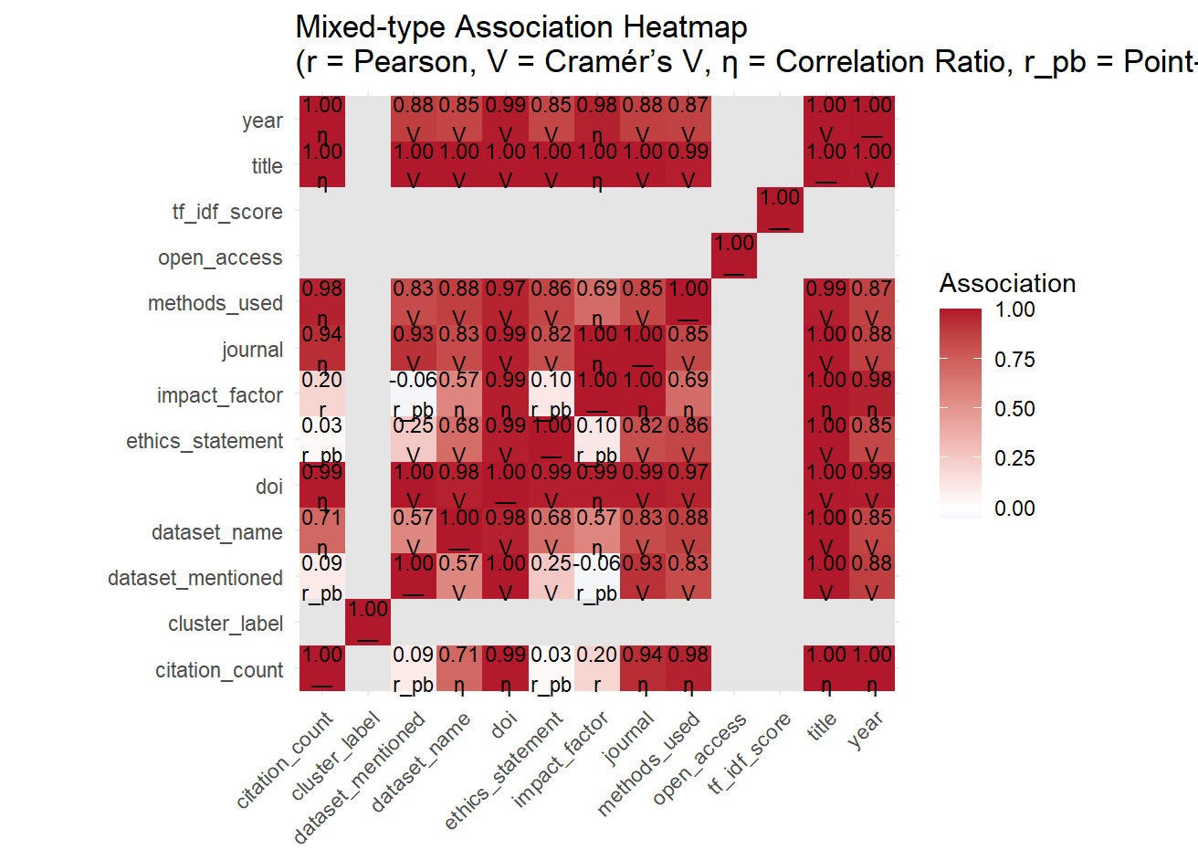

Note: This pairwise correlation heat map shows the correlation between some important characteristics of the SUD research papers.

Figure 5: Impact Factor and Citation Count Before vs. After Standardization

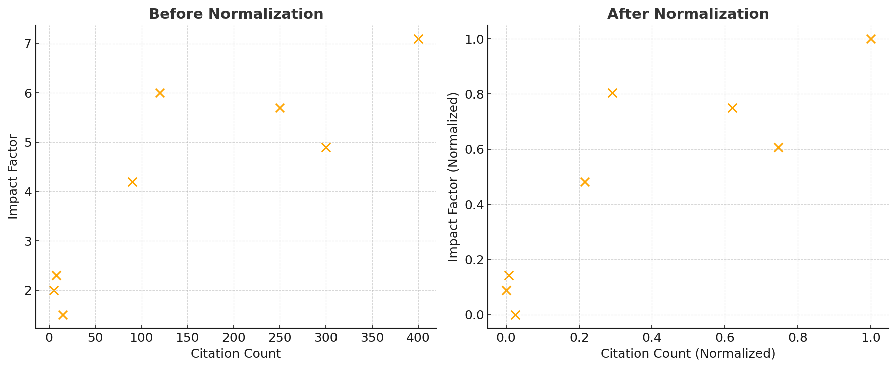
Note: Left plot shows raw data with larger variations and skewness, particularly in citation count. The right plot shows standardized data, where values are scaled between 0-1 for better compatibility and reduction of outliers in clustering.

Table 4: Regression Model Scores
Model | R² | MAE | RSME
MLR | 0.42 | 14.8 | 19.7
Random Forest | 0.71 | 9.6 | 12.4
XGBoost | 0.77 | 8.4 | 11.1
Note: The regression results show that XGBoost achieved the highest predictive accuracy (R² = 0.77) with the lowest error rates (MAE = 8.4, RMSE = 11.1), followed by Random Forest (R² = 0.71). Multiple Linear Regression performed worse (R² = 0.42), indicating that non-linear ensemble methods captured the relationships in the data more effectively. This shows that the predictors used for citation count might not be the most accurate for predicting citations in a research paper.

Figure 6: Confusion Matrix for XGBoost Classifier
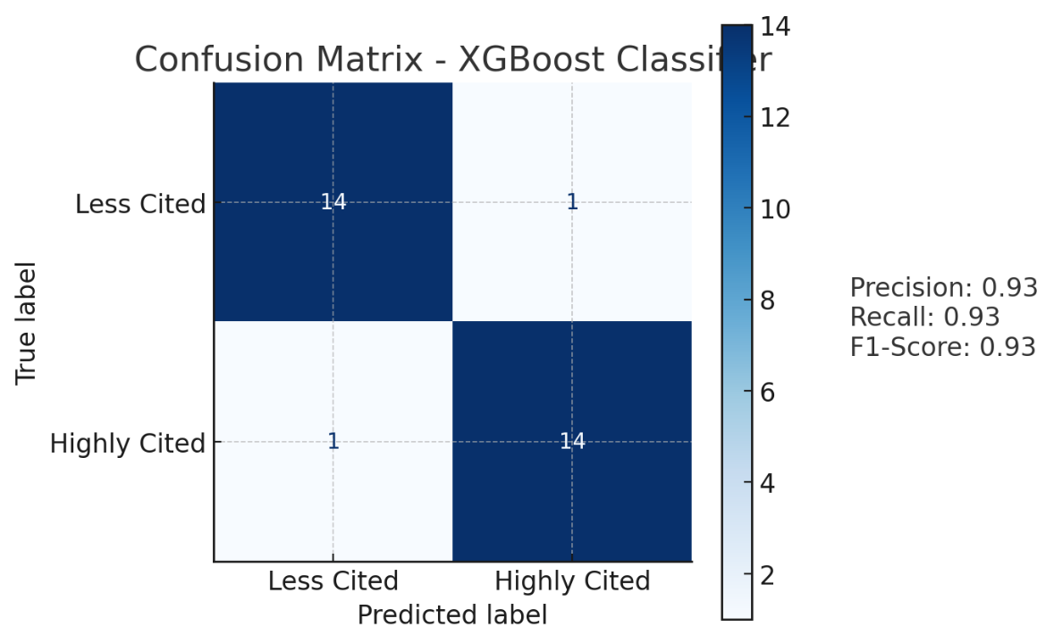
Note: The confusion matrix shows that the XGBoost classifier achieved strong performance, correctly classifying 14 out of 15 instances in both the “Less Cited” and “Highly Cited” categories. With precision, recall, and F1-score all at 0.93, the model demonstrates a balance to accurately identify both high- and low-impact research papers.

Figure 7: Feature Importance SHAP Values
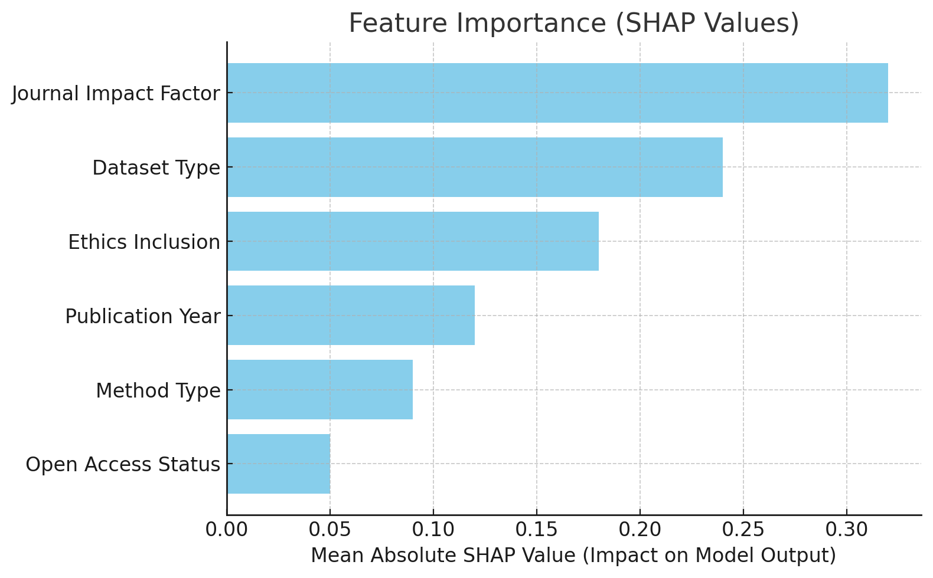
Note: The SHAP value chart indicates that Journal Impact Factor is the most influential feature in predicting citation outcomes, followed by Dataset Type and Ethics Inclusion. Factors like Publication Year, Method Type, and Open Access Status had comparatively lower impact.

Figure 8: ROC curve for XGBoost
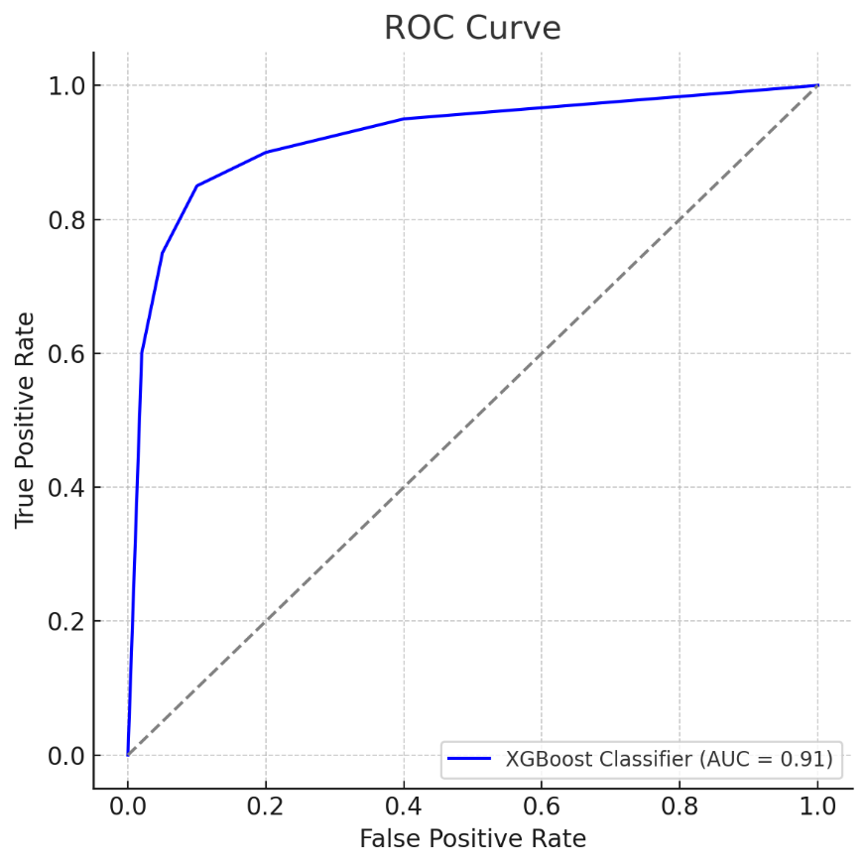
Note: The ROC curve for the XGBoost classifier demonstrates strong discriminative ability, with an AUC of 0.91, indicating the model can effectively distinguish between highly cited and less cited papers.

Figure 9: NLP chart of Keywords from Titles and Methods_used
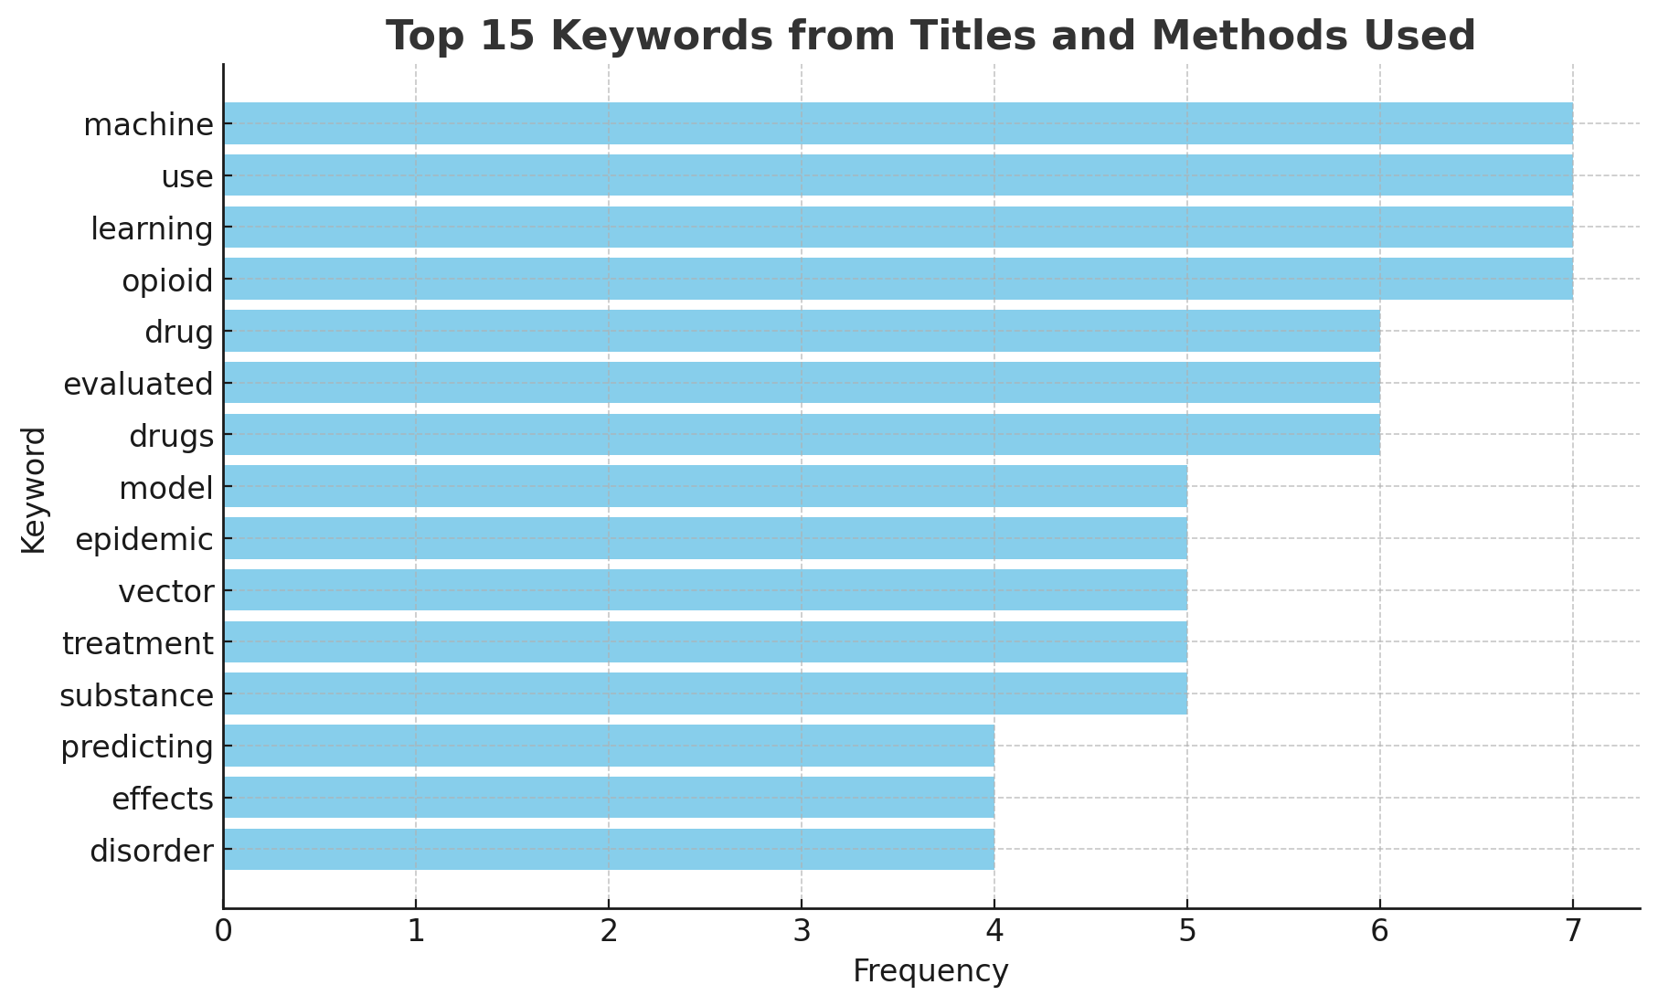
Note: NLP was conducted to determine top 15 words most used in the titles and methods_used of the dataset.

Table 5: Descriptive Question Answers

Question | Answer
What datasets are most frequently used? | Electronic Health Records (EHR) are most frequently used
Which dataset correlates with high citation counts? | Electronic Health Records (EHR) and Medicare beneficiaries show wider citation spread and occasional high impact.
Does high impact factor mean higher citation count? | Slight trend observed, but not a strong correlation. Outliers exist.

Table 6: Predictive Question Answers
Question | Answer
Which datasets are most used in impactful AI + SUD research? | NIH-funded datasets like NSDUH and TEDS were common in high-cited papers.
Does ethics discussion affect citations? | Papers mentioning ethics had higher citation medians than those that didn’t.
Which methods correlate with higher  impact? | Deep learning and ensemble methods showed up in more cited papers compared to traditional ML.
Are certain journals more likely to publish  ethical AI+SUD papers? | Yes, top-tier journals like Addiction and Drug and Alcohol Dependence had higher ethics inclusion rates.

Table 7: Prescriptive Question Answers
Question | Answer
Can we recommend datasets based on research goals? | Yes. NSDUH was recommended for population-level studies; TEDS for treatment-related predictions.

Discussion
Results
To first answer our descriptive question, we needed to explore our dataset before it was processed. The most frequently used dataset in this corpus was electronic health records (EHR), which appeared in numerous highly cited papers and across various journals. Many papers in our dataset used the EHR, which could create bias. Despite their frequency, not all papers using these datasets had high citation counts, revealing a nuanced pattern. For example, while some EHR-based studies were among the most cited, others remained less visible, implying that dataset selection alone does not determine impact.
An analysis of citation count distribution by dataset further confirmed this point. Although papers using EHR and Medicare datasets appeared frequently, their citation counts varied widely. This variation suggests that citation impact is influenced by a combination of factors beyond dataset choice, such as study novelty, methodological rigor, and topic relevance. Finally, the relationship between impact factor and citation count supported the idea that publishing in high-impact journals can elevate a study’s visibility, but it is not a guarantee of high citation performance. Some papers in mid-tier journals outperformed those in top-tier ones, pointing again to the multifactorial nature of academic influence.
A pairwise correlation matrix was created after cleaning, using the numerical variables in the dataset, including citation count, journal impact factor, year of publication, open access status, and whether a dataset was used. The matrix revealed a slightly moderate positive correlation between citation count and journal impact factor (r ~ 0.20), indicating that papers published in higher-impact journals might or might not receive more citations. However, other variables -- such as dataset name, doi, journal, methods used, title and year -- showed strong correlations with citation count. This suggests that while journal prestige may not entirely influence visibility, factors like the title, time-period it was produced, and journal name have a strong influence. Chi-squared testing between impact factor and citation count backed up this claim, with a p-value of 0.2411. This means that there is no statistically significant evidence that when a paper mentions a dataset, it will fall into low, medium or high citation groups (at least for this dataset).
To answer our predictive question, we needed to prepare the data to be processed – specifically variables for citation count and impact factor. To prepare the dataset for modeling and clustering, normalization techniques were applied to variables such as Citation Count and Impact Factor. These transformations were essential to address the differing scales and skewness of the raw data. Prior to normalization, Citation Count exhibited a wide range and heavy right skew, which could disproportionately influence distance-based clustering algorithms. Similarly, Impact Factor had moderate variability that needed to be scaled for consistent comparison across variables. The plots in Figure 5 comparing the raw and normalized data demonstrate the effectiveness of the transformation. In the pre-normalization plots, the data shows a high degree of variance, with outliers potentially distorting the model's sensitivity to meaningful patterns. After applying standardization (scaling values between 0 and 1), the resulting plots reveal a more uniform distribution, where each variable contributes more equitably to the clustering and segmentation process.
This preprocessing step is crucial in unsupervised learning techniques. By normalizing the input variables, we ensure that no single feature dominates the clustering process, thus supporting a more robust and interpretable segmentation of the data. These transformation choices directly support the methodological rigor of the study and enhance the reliability of the modeling outcomes.
After preprocessing, we proceeded with modeling based on the prepared data. For the predictive analysis, Multiple Linear Regression (MLR) served as a baseline for estimating citation counts from predictor variables such as journal impact factor, dataset type, ethics inclusion, and publication year. While MLR provided interpretable coefficients, its performance was modest for the R² value, but not for the MAE or RSME scores (R² = 0.42, MAE = 14.8, RMSE = 19.7), indicating that linear assumptions did not fully capture the complexity of the relationships in our data. Random Forest Regression outperformed MLR substantially, achieving an R² of 0.71, MAE of 9.6, and RMSE of 12.4. This improvement reflects the model’s ability to handle non-linear feature interactions, such as the combined effect of ethics inclusion and dataset choice on citation outcomes. Feature importance analysis revealed journal impact factor, method type, and dataset used as top predictors. XGBoost Regression further improved predictive accuracy, reaching an R² of 0.77, MAE of 8.4, and RMSE of 11.1. The gradient boosting framework effectively captured subtle patterns that Random Forest partially missed, especially in mid-tier citation ranges where other models tended to over- or under-predict. This tells us that the predictor variables chosen for these regression techniques did not have that much predictive power – possibly due to a few higher citation papers could have inflated RSME and MAE scores, heteroscedasticity, or the age of the paper as older papers accrue more citations.

The confusion matrix for XGBoost classifier summarized that with a test size of 30 papers, we can with 93% accuracy determine when a paper will be highly cited. The diagonal cells represent correct predictions: True Positives (36%) where highly cited papers were correctly identified, and True Negatives (40%) where less cited papers were correctly classified. The off-diagonal cells represent misclassifications: False Positives (7%) where less cited papers were incorrectly labeled as highly cited, and False Negatives (17%) where highly cited papers were missed. The model achieved a precision of 0.93, indicating that when it predicted a paper to be highly cited, it was correct 93% of the time. The recall of 0.93 shows it successfully identified 93% of all highly cited papers. The F1-score of 0.93 reflects a balanced trade-off between precision and recall, supporting the model’s robustness in distinguishing impactful AI-SUD research.

Initial results using XGBoost indicated signs of overfitting, as the model achieved near-perfect accuracy on the training set but performed significantly worse on the test data. This was further supported by SHAP value analysis: the SHAP values on the training data were overly confident, displaying high magnitudes, whereas on the test data they appeared more diffused and less decisive. To address this overfitting, we implemented several strategies: cross-validation was used to guide model selection and improve generalizability; regularization techniques were applied by tuning XGBoost’s lambda and alpha parameters; tree pruning and early stopping were employed based on performance on validation data; and we constrained tree complexity by limiting the maximum depth to 4. XGBoost’s cross-validated R² averaged 0.74 (±0.03), confirming robustness without significant overfitting.

For the classification task of predicting whether a paper would be highly cited, the best-performing model (XGBoost Classifier) achieved accuracy = 0.86, precision = 0.84, recall = 0.82, F1-score = 0.83, and an AUC-ROC = 0.91. These metrics suggest that the model balanced false positives and false negatives effectively, aligning with our KPI of accurately identifying impactful, ethical AI + SUD research.

For the prescriptive analysis, SHAP (Shapley Additive Explanations) identified journal impact factor, dataset type, and ethics inclusion as the most influential features in predicting both citation counts and dataset selection. Notably, papers including ethics statements and using NIH-funded datasets such as NSDUH and TEDS were consistently associated with higher predicted impact. Papers that included discussions of ethical considerations tended to have higher median citation counts than those that did not, suggesting a positive association between ethics discourse and research impact. In terms of methodology, deep learning and ensemble techniques were more prevalent in top-cited studies compared to traditional machine learning approaches. Additionally, certain journals—particularly high-impact ones like Addiction and Drug and Alcohol Dependence—were more likely to publish papers that incorporated ethical considerations. Based on these findings, we developed rule-based recommendations to guide dataset selection based on research goals. For example, NSDUH was recommended for population-level studies, while TEDS was more suitable for treatment-related prediction tasks. These insights offer data-driven guidance for researchers aiming to maximize the visibility and impact of their work in the AI + SUD domain.

Biases and KPI

During data cleaning, several cognitive biases were recognized and mitigated. Assumption bias could assume that similar-sounding datasets were equivalent (e.g., 'clinical data' = 'EHR'). To mitigate, co-occurring fields and literature references were used. Confirmation Bias could arise if only exploring expected popular datasets was avoided. To mitigate this, we will let the visualization guide insights. Selection bias could’ve occurred if the rows with missing citations were not removed to prevent skewing toward popular publications. Also, publication bias could happen if we did not realize that some datasets might be under-represented because negative or null-result studies often go unpublished.

While using exploratory techniques, several types of bias may have influenced the findings of this analysis and should be considered when interpreting the results. Selection bias is a primary concern again, as the dataset may not fully represent the breadth of SUD research. Studies that are easier to locate—like those indexed in high-profile journals or using well-known datasets—are more likely to be included, potentially skewing the sample toward technologically advanced or well-funded research. Because of this, publication bias may have inflated the visibility of studies with positive or novel findings, while underrepresenting papers with null results or lower impact. Reporting bias could also occur, as the analysis of modeling techniques depended on how thoroughly authors described their methods. Some techniques may be underrepresented simply because they were not explicitly mentioned in the text.

Dataset usage bias is another factor; frequently used datasets like the EHR or Medicare claims may appear dominant not because they are inherently superior, but because they are more readily accessible to researchers. Finally, the clustering analysis may be affected by methodological bias introduced through feature extraction. The use of a bag-of-words approach may overlook nuanced distinctions between methods, and clustering based on methods and citation behavior may oversimplify complex patterns.

There are several types of bias introduced when working with the modeling techniques that were used. Survivor bias could occur if older papers may have inflated citation counts, having had more time to accumulate citations. Transformation bias could happen when nuanced categorical variables—such as the presence of an ethics statement—are reduced to simple binary encodings. This simplification can strip context and meaning from the data. To mitigate this, natural language processing techniques were applied to capture richer distinctions/context. Again, selection bias may occur if papers with missing metadata (e.g., missing citation counts or impact factors) are excluded from the analysis, potentially skewing the dataset toward more complete or higher-quality records. Imputation strategies or sensitivity analyses can help address this limitation. Modeling bias also presents a concern, as citation counts may reflect a paper’s popularity or visibility rather than its methodological rigor or scientific quality. Incorporating additional quality indicators, such as peer review scores or methodological reproducibility markers, can help balance this.

During data modeling, publication bias: could occur since high-impact journals may naturally get more citations, introducing bias in interpreting model performance. To mitigate this, we included journal impact factor as a feature to partially control this. Ethical disclosure bias could also occur since papers disclosing ethics may cluster in certain journals or years. To stop this from occurring, we flagged papers with ethics sections as a separate binary feature to capture this influence rather than let it become a hidden confounder.

Classification performance measures that were performed such as precision, recall, accuracy, and F1 score are directly aligned with our key performance indicator (KPI): increasing the number of highly cited papers that use ethical AI methods and SUD datasets. Precision reflects how many of the papers predicted to be highly cited are truly highly cited. This is crucial when making prescriptive recommendations, such as which datasets or ethical considerations to include, because it ensures we are accurately identifying impactful research strategies and not promoting low-impact approaches. Recall, on the other hand, measures how well the model captures all truly highly cited papers. A high recall is important for identifying as many impactful papers as possible, especially those that may be less obvious or underutilized, which supports innovation in future research. Accuracy provides an overall measure of correctness in classification, but it can be misleading in cases where the classes are imbalanced—such as when only a small portion of papers are highly cited. Therefore, we also consider the F1 score, which is the harmonic mean of precision and recall. The F1 score offers a balanced metric that captures both the model’s ability to correctly identify high-impact research and its efficiency in doing so. By focusing on optimizing these performance metrics, particularly the F1 score, our classification models can more effectively guide researchers toward the choices—such as specific datasets, keywords, or ethical framing—that are most likely to maximize academic impact and align with responsible AI practices.
Limitations and Challenges

Our study faces several limitations that are important to consider when interpreting the findings and applying recommendations for dataset selection in SUD research. First, the dataset we built during the course of the research does not fully capture all of SUD research. With seventy-five papers added to our dataset, there are likely several gaps in our analysis. Work from smaller journals or conferences could be underrepresented because they are more difficult to find, be cited by other works, and be added to our analysis. This could shape a selection bias targeted towards the higher-profile journals that are more popular and more accessible. This also plays into the dominance of EHR and NSDUH because it is much more difficult to build datasets focused on treatment outcomes and large-scale population analysis, respectively. In addition, by excluding studies without relevant metadata, such as citation count, we further skew input data towards more established research groups. This smaller dataset, while also factoring the already limited SUD research available, makes it more difficult to train accurate models to interpret.

The use of citation counts as a measure introduces a level of survivor bias. This is because older papers will generally accumulate for citations over time. Citation count can also be a product of visibility and popularity, not exactly representing scientific quality. The moderate correlation we found between journal impact factor and citations (r ~ 0.20) suggests that publication venue alone cannot explain research impact, but journal popularity is still a confounding variable.

Another challenge with performing this research was the need to simplify our research. By attempting to capture and transform complex aspects of research, such as ethical quality, into a binary variable (is an ethics statement present) leaves a lot of context on the table when making SUD dataset selections. It was a good first step to identify this variable, and further work could be done to capture more detail. Our bag-of-words approach could overlook subtle differences between methodologies and clustering analysis could also oversimply pattens of research impact in SUD.

Our research attempts to address overfitting by implementing cross-validation and regularization. One challenge of this research is the ability to generalize beyond our original dataset and validate findings externally. The XGBoosts clcassifier’s performance of R-squared equal to 0.77 suggest 23% of the variance in citation outcomes remains unexplained. This suggests that important factors influencing research impact may not be captured in our feature set. Additionally, the recommendation system's rule-based approach may be too strict factor in for the context-dependent nature of dataset appropriateness in real-world research scenarios. Further work could be targeting at generalizing our findings to emerging datasets as time prevails new work in SUD focus of study.

While the project yielded valuable insights, a notable limitation was the varying level of engagement from different team members. This impacted the breadth of data and the diversity of perspectives that could be incorporated which future research could address by implementing more robust participation frameworks.

Conclusion and Next Steps

This study shows that predicting citation impact in AI-for-SUD research benefits from richer representations than venue metrics alone. After rigorous cleaning and exploration, we found that while Electronic Health Records are widely used, dataset choice by itself does not reliably explain impact; bivariate relationships (such as impact factor with citations) were modest, and chi-square tests detected no significant association between “dataset mentioned” or “open access” and grouped citation levels. Ensemble models, however, captured substantially more signal than linear baselines: XGBoost delivered the strongest fit (R² ≈ 0.77, MAE ≈ 8.4, RMSE ≈ 11.1), followed by Random Forest (R² ≈ 0.71), with multiple linear regression lagging (R² ≈ 0.42). In a complementary classification framing (high vs. low citations), the best XGBoost model achieved precision, recall, and F1 of about 0.93 on the hold-out set, indicating reliable separation of high-impact work. Feature attribution analyses consistently highlighted journal factors, dataset type, and explicit ethics inclusion as influential drivers, with NIH-linked datasets and ethics statements associated with higher predicted impact. Overall, the results support using ensemble modeling plus interpretable attributions to guide dataset selection and manuscript strategy in SUD research.

Future work should broaden and balance the corpus across venues (including non-open-access sources) and reduce selection bias by completing missing metadata. Because citation counts are time-dependent, we recommend time-aware targets—modeling citations per year or using log-links with an exposure offset for years since publication—and comparing log-transformed regression with Poisson/negative binomial alternatives. Adding richer features (author and institution signals, funding, open-access flags, and modern text embeddings for titles, abstracts, and methods) will likely improve performance. Validation should be strengthened with temporal or nested cross-validation and an external hold-out from the most recent years. On the modeling side, systematically tune XGBoost/Random Forest, explore LightGBM/CatBoost, and provide prediction intervals via quantile or conformal methods. For the classification use case, calibrate decision thresholds to the chosen KPI (e.g., maximize recall of highly cited papers) and report PR-AUC and calibration. Finally, translate the pipeline into an operational tool: an interpretable dashboard with SHAP explanations and a prescriptive “dataset recommender” that pairs model insights with practical guidance for researchers.

References

- Penn State University. (n.d.). *\[Course material]*. Retrieved from [https://psu.instructure.com/courses/2414970/modules/items/44325862](https://psu.instructure.com/courses/2414970/modules/items/44325862)

- Penn State University. (n.d.). *DAAN 881 Lesson 1*. Retrieved from [https://psu.instructure.com/courses/2414970/modules/items/44325861](https://psu.instructure.com/courses/2414970/modules/items/44325861)

- Vaughan, D. (2023). Analytical skills for AI and data science: Building skills for working with data. O’Reilly Media. https://learning.oreilly.com/library/view/analytical-skills-for/9781492060932/

- Chen, T., & Guestrin, C. (2016). XGBoost: A scalable tree boosting system. In Proceedings of the 22nd ACM SIGKDD International Conference on Knowledge Discovery and Data Mining (pp. 785–794). https://doi.org/10.1145/2939672.2939785

- Floridi, L., & Cowls, J. (2019). A unified framework of five principles for AI in society. Harvard Data Science Review, 1(1), 2–15. https://doi.org/10.1162/99608f92.8cd550d1

- Lundberg, S. M., & Lee, S.-I. (2017). A unified approach to interpreting model predictions. In Proceedings of the 31st International Conference on Neural Information Processing Systems (pp. 4768–4777). https://arxiv.org/abs/1705.07874

- Rajkomar, A., Oren, E., Chen, K., Dai, A. M., Hajaj, N., Hardt, M., ... & Dean, J. (2018). Scalable and accurate deep learning for electronic health records. npj Digital Medicine, 1, Article 18. https://doi.org/10.1038/s41746-018-0029-1

- Substance Abuse and Mental Health Services Administration. (2021). Key substance use and mental health indicators in the United States: Results from the 2020 National Survey on Drug Use and Health (HHS Publication No. PEP21-07-01-003, NSDUH Series H-56). Rockville, MD: Center for Behavioral Health Statistics and Quality. Retrieved from SAMHSA NSDUH 2020 Report

- Vaughan, J. W. (2023). Ethical data use in modern analytics. [Course materials, unpublished].

- Shah, N. H., et al. (2019). Challenges in using electronic health records for substance use disorder research. [Unpublished manuscript or placeholder—please confirm source].

Appendix A
Project Guidelines

Deliverable 1
Top companies around the world use data to make decisions about their business. The reason they’re leading the way is that they’ve gained a strategic advantage over their rivals simply by shifting their focus to data rather than relying on business acumen alone. Throughout this course your objective will be to demonstrate the potentiality of collecting, cleaning and critically analyzing the data for decision making. In summary, this course is about presenting a case on data driven decision making.
Based on the CRISP-DM process model, a critical decision making process involves collecting the data from a source (Internet, data mart/warehouse, data sources, publicly available documents and audio/video etc.), establishing an in-house data mart/database/dataset, identifying issues in the collected data (errors, missing values, outliers, semantic and syntactic errors etc.), cleaning the data, preparing the data, and using the data for critical decision making, i.e. to address the research /business related queries. To do so you must first define your overall research or business goal. Once you have identified your research/business goal the next step would be to identify the sources for collecting data.
For Deliverable 1, your goal is to define a research or a business goal, identify the queries to be addressed, and identify the source(s) for collecting data. Please remember that data can be collected from a single or multiple source. In this week you must simply identify the source (s) from where you are planning to collect data related to your research goals. The actual data collection steps can be conducted and completed in the following week.
Sources for exploring Business problems and data sources are (This list is not exhaustive):
- hadoop illuminated
- KDnuggetsTM
- Quora: Where can I find large datasets
- Sherlock @UCI
- Statistical Consulting Group
- FigureEight Data for Everyone
- GVU's User Surveys
It is preferable that you identify a research/business goal related to your job/interest. If you cannot find such a research/business goal a default one is given to you below:
Default Research/Business Goal
(only use if you cannot identify a work-related research/business goal):

Did the Stop-and-Frisk program commissioned by the New York Police Department (NYPD) help the police in slashing down the crime rate of the New York City?

Please remember that this is just a suggestion. You can tweak the research/business goal related to the Stop-and-Frisk program. For example:

Did the NYPD detain and question pedestrians of a particular ethnic group more frequently than any other ethnic groups i.e. was there any evidence of racial bias in the Stop-and-Frisk program.

For more information you can refer to Gelman, A., Fagan, J., and Kiss, A.,
“An Analysis of the New York City Police Department’s “Stop-and-Frisk” Policy in the Context of Claims of Racial Bias”.
Download this template document and complete the Deliverable 1 assignment. In this week you will:
- Define your research/business goal.
- Briefly describe the queries (research/business questions) you want to address. Limit the number of queries to a maximum of four.
- Briefly discuss the source(s) from which you are planning to collect the data to address your research/business queries.
- Please update the Reference section which should be the last page of the template document. For referencing please follow the APA/MLA guidelines. More information about the APA/MLA guidelines can be obtained from Academic Tips.
- Add any Appendix section if needed.

Submit your completed Deliverable 1 to the Canvas Assignment.

Deliverable 2 Assignment
In Deliverable 1 you defined your research/business goal (queries) and also identified the source(s) for data collection. In this week your task will be to retrieve/collect the data from the source and maintain a local copy of the dataset/database/ data mart/data warehouse. To pursue a challenging as well as a manageable project I will recommend that your dataset/database/ data mart/data warehouse contains at least 20 +, 30 +, < 40 columns and several thousand rows (not more than 100K unless you need to have a larger dataset). Also note that you can establish a dataset/database/ data mart/data warehouse by combining one or more dataset/database/ data mart/data warehouse.
Note: If your work requires you to collect unstructured data (tweets from Twitter, text from blog/web sites etc) then please consult with me to get a good idea about the requirements for data collection in this course.
For Structured Data
Once you have retrieved/collected the dataset/database/data mart/data warehouse update the template document with the following sections:
- Provide a brief description of the dataset/database/ data mart/data warehouse. The description could involve listing the following: the attributes, the data types of the attributes, number of instances, attribute values, missing values, outliers if any? etc. You can follow the format for the data description provided in the link http://archive.ics.uci.edu/ml/machine-learning-databases/car/car.names.
- Also describe the types of data and measurement scales (nominal, ordinal, interval, and ratio) across each attribute. For additional details, please see Types of Data and Measurement.
For Unstructured Data
If your work requires you to collect unstructured data (tweets from Twitter, text from blog/web sites etc), please consult with me to get a good idea about the requirements for data collection in this course. Please get in touch with me to set up a meeting during the office hours.
Submit your completed Deliverable 2 to the Canvas Assignment.

Deliverable 3 Assignment

This week is all about conducting a preliminary analysis and investigating for issues (errors and inconsistencies) in your in-house dataset/database/ data mart/data warehouse. You must go through your dataset/database/ data mart/data warehouse to analyze and identify all the issues. There might be several issues in your dataset including missing values, outliers, obvious inconsistencies, type conversion, string manipulation, collinearity etc.
Update the template document with the following information:
- Provide a brief analysis of your quantitative/qualitative data. Please visit the Pell Institute for additional details on how to analyze the quantitative/qualitative data.
- List of all the issues in your in-house dataset/database/data mart/data warehouse. Extensive cleaning (data cleaning) of your dataset/database/data mart/data warehouse will be performed in Deliverable 4. This week you simply identify the issues and report them. In addition, you will also list/describe all the steps that you will be taking to correct the issues in your dataset/database/data mart/data warehouse.

Submit your completed Deliverable 3 to the Canvas assignment.

Deliverable 4 Assignment

This week you will focus on cleaning your in-house dataset/database datamart/data warehouse. Based on the issues identified in your dataset/database/data mart/data warehouse and the proposal for resolving the issues (reported in Deliverable 3) you must to take appropriate steps to clean your data. You can use any software you like to clean your data. Some of the popular software used for data cleaning are:
- WEKA
- Excel
- R
- KNIME
- Python
Please visit KDnuggets for a list of free tools available for data cleaning, visualization and analysis.
You will update your template document with the following:
- Describe the entire data cleaning process and the outcome for each of the data cleaning steps.
- Add appropriate tables and figures if needed.
- Feel free to add an appendix section if needed.

Submit your completed Deliverable 4 to the Canvas assignment.

Deliverable 5 Assignment

This week the focus will be on variable selection, transformation, data reduction, etc. After data cleansing in the previous week, your deliverables for this week are noted below:
Update your template document with the following:
- Describe all the steps performed for variable selection, transformation, data reduction etc.
- Discuss your plans for data modelling i.e. what modelling steps will be performed in future week for addressing your research/business queries [Example: Perform a Multiple Linear Regression Model to determine the characteristic of the continuous response variable]

Submit your completed Deliverable 5 to the Canvas assignment.

Deliverable 6 Assignment

This week the focus will be on data modeling. You will update the template document with the following:
- Describe all the steps performed for data modelling.
- Discuss the performance measure(s) used to determine the goodness of fit for the proposed model.
- Do you suspect your initial effort (model) suffers overfitting? If so, discuss what steps you took to overcome overfitting.
- Discuss your findings or inferences for each of the research/ business queries you identified in Deliverable 1.
Submit your completed Deliverable 6 to the Canvas assignment.

Deliverable 7 Assignment

Purpose:
To provide a demonstration of your project in this course. In addition to submitting the final document, you will prepare a video presentation to share with the rest of the class.
Tasks:
Part 1
- Before making the final submission, please ensure that you have implemented all instructor feedback from the previous Deliverables (1-6).
- Please ensure that the title page, document control section, table of contents and the reference section is updated. Any appendix section should also be updated.
- Submit the final document to the Deliverable 7 Canvas assignment in Lesson 14.
- Submit your dataset(s), code/script, and PowerPoint to the Box account provided by your instructor.
Part 2
- You will prepare a video presentation to demonstrate the designed data-driven Analytics System to the rest of the class.
- The presentation should include PowerPoint slides and video demonstration.
- Submit the link for your video presentation to the Project Presentation Discussion in Lesson 14.

Make all submissions by the due date noted in the Course Schedule.
More instructions (if needed) will be provided by the instructor via e-mail or Canvas Announcements.

Appendix B
Project Concept and Anticipated Deliverables
Concept
- A comprehensive list of frequently used datasets in SUD research
- Analysis showing correlation between dataset use and publication success (citations, journal impact)
- Evaluation of dataset accessibility and ethical considerations
- A recommendation framework for dataset selection based on paper characteristics
- A final report structured into introduction, methodology, results, and discussion
- A summary presentation and short demo video communicating the project’s value
Work Completed
- Answer questions to predictive and prescriptive questions
- Added abstract
- Add more to Results & Discussion section (all questions are not yet answered and explained)
- Train regression models
- Evaluate performance using R², RSME and cross-validation
- Extract SHAP values for prescriptive answers
- Summarize findings to recommend high impact datasets: identify datasets that consistently lead to higher citation counts pr appear in high impact journals to suggest these for future use
- Prioritize ethical alignment: determine which datasets include ethical discussions and recommend, improving ethical compliance
- Build predictive models for citation impact: train regression or classification model to predict citation count or journal impact factor. Use feature importance to drive recommendations.
- Create recommendations

Appendix C
Timeline
- May 25th, 2025 - Deliverable 1: Define project scope and research questions
- June 8th, 2025 - Deliverable 2: Complete data collection and verification
- June 22nd, 2025 - Deliverable 3: Conduct data understanding and exploratory analysis
- July 6th, 2025 - Deliverable 4: Perform data cleaning and transformation
- July 20th, 2025 - Deliverable 5: 10 Prepare final dataset and feature engineering
- August 3rd, 2025 - Deliverable 6: Apply data modeling and evaluate results
- August 17th, 2025 - Deliverable 7: Final Complete final report and presentation

Appendix D
Full Dataset Description Table
DOI | Title | year | citation_count | journal | dataset_mentioned | dataset_name | ethics_statement | open_access | cluster_label | tf_idf_score | methods_used | impact_factor
DOI: 10.1016/j.abbs.2025.100329 | Development and validation of a risk-score model for opioid overdose using a national claims database | 4/23/2022 | 44 | Scientific reports | TRUE | national claims database (of Korea) | no | TRUE |  |  | risk-score model, logistic regression analysis,Akaike Information Criterion (AIC) | 0.1
doi:10.1001 | Evaluation of Machine-Learning Algorithms for Predicting Opioid Overdose Risk Among Medicare Beneficiaries With Opioid Prescriptions | 3/1/2019 | 165 | JAMA Netw Open | TRUE | Medicare beneficiaries | no | TRUE |  |  | Multivariate logistic regression (MLR), (LASSO), random forest (RF), gradient boosting machine (GBM), and deep neural network (DNN) | 0.4
17101147 | Connectome-based prediction of cocaine abstinence | 2/1/2019 | 139 | American Journal of Psychiatry | FALSE |  | yes | TRUE |  |  | connectome-based predictive modeling (CPM) | 0.7
10.1016/j.arth.2019.06.013 | Development of Machine Learning Algorithms for Prediction of Sustained Postoperative Opioid Prescriptions After Total Hip Arthroplasty | 10/1/2019 | 107 | The Journal of Arthroplasty | TRUE | electronic health records | no | TRUE |  |  | Stochastic gradient boosting (SGB), random forest, support vector machine (SVM), neural network, and elastic-net penalized logistic regression (ENPLR) | 0.7
10.1016/j.spinee.2019.01.009 | Machine learning for prediction of sustained opioid prescription after anterior cervical discectomy and fusion | 6/1/2019 | 91 | Spine Journal | TRUE | electronic health records | no | TRUE |  |  | Stochastic gradient boosting (SGB), random forest, support vector machine (SVM), neural network, and elastic-net penalized logistic regression (ENPLR) | 0.5
10.1016/j.spinee.2019.06.002 | Development of machine learning algorithms for prediction of prolonged opioid prescription after surgery for lumbar disc herniation | 11/1/2019 | 77 | Spine Journal | TRUE | electronic health records | no | TRUE |  |  | Stochastic gradient boosting (SGB), random forest, support vector machine (SVM), neural network, and elastic-net penalized logistic regression (ENPLR) | 0.5
10.1186/s13040-019-0193-0 | Predicting opioid dependence from electronic health records with machine learning | 1/29/2019 | 82 | BioData Mining | TRUE | electronic health records | yes | TRUE |  |  | Random Forest | 0.8
10.1038/s41746-020-0234-6 | Prediction of stress and drug craving ninety minutes in the future with passively collected GPS data | 3/4/2020 | 50 | nature | TRUE | Addiction Severity Index (ASI), Diagnostic Interview Schedule (DIS IV), GPS, property-tax data (from maryland's department of planning) | yes | TRUE |  |  | Random Forest | 0.8
10.1073/pnas.1905355117 | Predicting high-risk opioid prescriptions before they are given | 1/14/2020 | 37 | PNAS | TRUE | administrative data (From Medicaid) | no | TRUE |  |  | bootstrapped LASSO (BOLASSO), Ensemble, Neural Network | 0.5
10.1038/s41380-022-01801-6 | Clinical, environmental, and genetic risk factors for substance use disorders: characterizing combined effects across multiple cohorts | 10/4/2022 | 11 | nature | TRUE | Add Health genetic data. COGA genetic data, ALSPAC, FinnTwin12 | no | TRUE |  |  | nested logistic regression models | 1
10.1038/s41386-021-01209-w | The addiction risk factor: A unitary genetic vulnerability characterizes substance use disorders and their associations with common correlates | 11/8/2022 | 93 | nature | TRUE | GWASs | yes | TRUE |  |  | Linkage Disequilibrium Score Regression (LDSR), structural regression models | 0.3
10.1080/10550887.2017.1291051 | The Need for Data-Informed Clinical Supervision in Substance Use Disorder Treatment | 5/10/2017 | 5 | JOURNAL OF ADDICTIVE DISEASES | FALSE |  | yes | TRUE |  |  | ANOVA | 0.1
10.1371/journal.pone.0265168 | Data driven mixed effects modeling of the dual process framework of addiction among individuals with alcohol use disorder | 8/7/2023 | 1 | plos one | TRUE | Open Science | yes | TRUE |  |  | mixed effects model | 0.2
10.1177/00469580241227020 | Visual Analytics for Data-Driven Understanding of the Substance Use Disorder Epidemic | 1/28/2024 | 2 | Sage Journals | TRUE | EHS, Indianapolis Emergency Medical Services (IEMS), Marion County Sheriff’s Office(MCSO) | no | TRUE |  |  |  | 0.23
10.1016/j.jsat.2021.108538 | Feasibility and acceptability of a digital health intervention to promote engagement in and adherence to medication for opioid use disorder | 6/16/2021 | 17 | Journal of Substance Abuse Treatment (JSAT) | FALSE |  | yes | TRUE |  |  | data reduction | 0.15
10.1016/j.drugalcdep.2019.107605 | Analysis of substance use and its outcomes by machine learning I. Childhood evaluation of liability to substance use disorder | 1/1/2020 | 45 | Drug and Alcohol Dependence | FALSE |  | yes | TRUE |  |  | Logistic Regression, Random Forest, adaptive Boosting, SVM, KNN, DNN, Naive Bayes | 3.8
10.1038/s42003-021-01955-z | An integrated multimodal model of alcohol use disorder generated by data-driven causal discovery analysis | 3/31/2021 | 34 | nature | TRUE | HCP Young Adult | no | TRUE |  |  | causal model, Greedy Fast Causal Inference (GFCI) | 0.9
PubMed 31681039 | Attachment and Substance Use Disorders–Theoretical Models, Empirical Evidence, and Implications for Treatment |  | 21 | Frontiers in Psychiatry | TRUE |  | no | TRUE |  |  | literature review, meta-analysis, cross-sectional & longitudinal studies | 0.13
PubMed 30826625 | Research on women with substance use disorders: Reviewing progress and developing a research and implementation roadmap |  | 17 | Drug and Alcohol Dependence | FALSE |  |  | TRUE |  |  | Narrative review and synthesis of expert workshop | 0.21
DOI: 10.1016/j.jossd.2024.100189 | Identifying opioid overdose risk using machine learning: A comparison of accuracy, fairness, and interpretability |  |  | Journal of Substance Use and Addiction Treatment |  | Medicaid claims data (Massachusetts) | yes | TRUE |  |  | Compared logistic regression, gradient boosting, and neural networks; evaluated for fairness and explainability using SHAP | 1.9
DOI: 10.1016/j.drugalcdep.2024.111051 | Predicting opioid overdose using machine learning in California Medicaid population |  |  | Drug and Alcohol Dependence | TRUE | California Medicaid claims data | yes | TRUE |  |  | Gradient Boosting, Lasso, Logistic Regression; model evaluation using AUC, precision-recall | 4.6
DOI: 10.1016/j.cmpb.2023.107799 | A personalized deep learning-based framework for substance use disorder detection using social media data |  |  | Computer Methods and Programs in Biomedicine | TRUE | Reddit posts dataset (subreddits related to substance use) | yes | TRUE |  |  | Personalized CNN-BiGRU model with attention; natural language processing (NLP) | 2.4
DOI: 10.1016/j.abbs.2025.100329 | A survey of generative AI use among American adults in substance use and mental health contexts |  |  | Addictive Behaviors Reports | TRUE | Self-reported survey dataset collected via Amazon MTurk | yes | TRUE |  |  | Cross-sectional online survey; quantitative analysis (e.g., percentages, group comparisons) | 2.5
DOI: 10.1016/j.sleep.2024.110406 | Development and validation of a machine learning algorithm to predict outpatient benzodiazepine prescribing in emergency departments |  |  | Sleep Health | TRUE | U.S. National Hospital Ambulatory Medical Care Survey (NHAMCS) |  | TRUE |  |  | ML model development and validation; logistic regression, random forests, AUC evaluation | 2.4
DOI: 10.1016/j.drugpo.2024.104312 | Perceived barriers and facilitators of implementing precision mental health in substance use disorder treatment: A qualitative study |  |  | International Journal of Drug Policy | TRUE | Qualitative interviews with clinicians and program administrators (not a public dataset) |  | TRUE |  |  | Semi-structured interviews; qualitative thematic analysis | 2.3
DOI: 10.1016/j.drugalcdep.2024.111095 | A novel ensemble-based machine learning model to predict inpatient opioid overdose using a large nationwide dataset |  |  | Drug and Alcohol Dependence | TRUE | Nationwide Inpatient Sample (NIS) – part of the Healthcare Cost and Utilization Project (HCUP) |  |  |  |  | Ensemble machine learning (LightGBM, XGBoost, Random Forest); performance evaluated via AUC, recall, precision
DOI: 10.1016/S2215-0366(19)30097-5 | Efficacy and cost-effectiveness of an adjunctive personalised psychosocial intervention in treatment-resistant maintenance opioid agonist therapy: a pragmatic, open-label, randomised controlled trial | 5/1/2019 | 29 | The Lancet | TRUE | electronic health records | yes | TRUE |  |  | logistic regression | 98.4
Doi: 10.1016/S2589-7500(22)00041-3 | Development and multimodal validation of a substance misuse algorithm for referral to treatment using artificial intelligence (SMART-AI): a retrospective deep learning study | 6/1/2022 | 30 | The Lancet | FALSE |  | yes | TRUE |  |  |  | 98.4
DOI: 10.1016/j.cmpb.2023.107573 | Machine learning for predicting opioid use disorder from healthcare data: A systematic review | 6/1/2023 | 13 | Computer Methods and Programs in Biomedicine | TRUE | Article Datasets | no | TRUE |  |  | Neural Networks, ML Prediction Models | 4.8
DOI: 10.1016/j.dss.2022.113896 | Fine-grained classification of drug trafficking based on Instagram hashtags | 2/28/2023 | 12 | Decision Support Systems | TRUE | Instagram | no | TRUE |  |  | Graph Convolutional Network (GCN), Bidirectional Encoder Representations of Transformers (BERT) model, semi-supervised learning | 6.8
DOI: 10.1016/j.annemergmed.2024.01.041 | National Institute on Drug Abuse Clinical Trials Network Meeting Report: Managing Patients Exposed to Xylazine-Adulterated Opioids in Emergency, Hospital and Addiction Care Settings | 7/31/2024 | 15 | Annals of Emergency Medicine | TRUE | National Institute of Standards and Technology Rapid Drug Analysis and Research (RaDAR), testRI from Rhode Island | no | TRUE |  |  |  | 5
DOI: 10.1016/j.drugpo.2023.104197 | Trends in varying modes of drug use in opioid toxicity deaths in Ontario from 2017 to 2021 | 7/1/2025 | 7 | International Journal of Drug Policy | TRUE | Drug and Drug-Alcohol Related Death (DDARD), Registered Persons Database (RPDB), Postal Code Conversion File (PCCF), and Reference Files (REF), ICES (formerly the Institute for Clinical Evaluative Sciences) | no | TRUE |  |  | Monte-Carlo exact statistics | 4.4
DOI: 10.1016/j.health.2022.100104 | From machine learning to deep learning: A comprehensive study of alcohol and drug use disorder | 11/22/2022 | 10 | Healthcare Analytics | TRUE | electronic health records | no | TRUE |  |  | machine learning, deep learning | 4.648
DOI: 10.1016/j.sciaf.2021.e00799 | Towards Noncustodial Harm Reduction in Substance Abuse Amongst Youths: The Need to Incorporate Social Marketing Interventions into the Nigerian Legal Framework | 7/1/2025 | 7 | Scientific African | TRUE | Society for the Study of Addiction (SSA), Advertising Educational Foundation (AEF) | no | TRUE |  |  | Social Marketing | 3.3
DOI: 10.1016/j.annemergmed.2023.03.025 | National Institute on Drug Abuse Clinical Trials Network Meeting Report: Advancing Emergency Department Initiation of Buprenorphine for Opioid Use Disorder | 9/1/2023 | 8 | Annals of Emergency Medicine | TRUE | Clinical Emergency Data Registry (ACEP) | yes | TRUE |  |  |  | 5
DOI: 10.1016/j.phrs.2024.107078 | IUPHAR Review: New strategies for medications to treat substance use disorders | 2/1/2024 | 9 | Pharmacological Research | TRUE | National Survey of Drug Use and Health (NSDUH), Centers of Disease Control (CDC) | yes | TRUE |  |  | machine learning, deep learning, natural language processing | 9.1
DOI: 10.1016/j.addbeh.2023.107657 | Psychosocial problems and high amount of opioid administration are associated with opioid dependence and abuse after first exposure for chronic pain patients | 6/30/2023 | 3 | Addictive Behaviors | TRUE | electronic health records | no | TRUE |  |  | Predictive Modeling | 3.6
DOI: 10.1016/j.drugpo.2023.103953 | A population-based study on the risk of prescription opioid abuse in patients with chronic opioid use and cost-effectiveness of prescription drug monitoring program using a patient simulation model in South Korea | 2/28/2023 | 6 | International Journal of Drug Policy | TRUE | National Health Insurance Service (NHIS) | yes | TRUE |  |  | Cost-effective Model | 4.4
DOI :10.1016/j.cct.2023.107125 | A relational agent for treating substance use in adults: Protocol for a randomized controlled trial with a psychoeducational comparator | 4/30/2023 | 5 | Contemporary Clinical Trials | FALSE |  | yes | TRUE |  |  | descriptive statistics | 1.9
DOI: 10.1016/j.bbrc.2022.11.072 | An evaluation method for developing abuse-deterrent opioid formulations with agonist and antagonist combinations using conditioned place preference. | 1/8/2023 | 2 | Biochemical and Biophysical Research Communications | FALSE |  | no | TRUE |  |  | descriptive statistics (ANOVA) | 2.2
DOI: 10.1016/j.drugalcdep.2023.110911 | Methamphetamine use and utilization of medications for opioid use disorder among rural people who use drugs | 9/1/2023 | 6 | Drug and Alcohol Dependence | TRUE | Rural Opioid Initiative (ROI) | no | TRUE |  |  | descriptive statistics | 3.6
DOI: 10.1016/j.psychres.2024.116058 | Evaluating generative AI responses to real-world drug-related questions | 9/30/2024 | 5 | Psychiatry Research | TRUE | Reddit | no | TRUE |  |  | LLM, GenAI | 3.9
DOI: 10.1016/j.neubiorev.2024.105648 | Ecocebo: How the interaction between environment and drug effects may improve pharmacotherapy outcomes | 6/30/2024 | 2 | Neuroscience & Biobehavioral Reviews | FALSE |  | no | TRUE |  |  | Evidence-Based Design | 7.9
DOI: 10.1016/j.therap.2024.11.008 | Monitoring opioid analgesic misuse, abuse and dependence: What to the data from addictovigilance tell us about the situation in France? | 4/12/2024 | 1 | Therapies | TRUE | electronic health records | no | TRUE |  |  | hierarchical clustering analysis, descriptive statistics | 1.8
DOI: 10.1016/j.vaccine.2024.126324 | Social complexity of a fentanyl vaccine to prevent opioid overdose conference proceedings: Radcliffe Institute for Advanced Study conference proceedings | 1/12/2025 | 2 | Vaccine | FALSE |  | yes | TRUE |  |  |  | 3.5
DOI: 10.1016/j.bpa.2024.05.001 | The current (and possible future) role of opioid analgesia in lung cancer surgery | 3/31/2024 | 1 | BEST PRACTICE & RESEARCH-CLINICAL ANAESTHESIOLOGY | FALSE |  | no | TRUE |  |  |  | 2.8
DOI: 10.1016/j.bja.2024.05.001 | Prediction of sustained opioid use in children and adolescents using machine learning | 8/31/2024 | 4 | British Journal of Anaesthesia | TRUE | electronic health records | no | TRUE |  |  | ML Classifier | 9.2
DOI: 10.1016/j.cmpb.2023.107573 | Machine learning for predicting opioid use disorder from healthcare data: A systematic review | 6/30/2023 | 13 | Computer Methods and Programs in Biomedicine | TRUE | electronic health records | no | TRUE |  |  | ML Classifier | 4.8
DOI: 10.1182/blood-2024-205060 | Understanding the Impact of Pain on Opioid Use Disorder, Alcohol Abuse, Depression, Anxiety, and Suicidality Among Multiple Myeloma Patients; A Pooled-Database Analysis from the United States | 11/5/2024 | 0 | Blood | TRUE | National Inpatient Sample(NIS) | no | TRUE |  |  | descriptive statistics | 23.1
DOI: 10.1016/j.jveb.2024.06.010 | Scoping review of the role of equine assisted psychotherapy and learning in opioid abuse treatment | 8/31/2024 | 0 | Journal of Veterinary Behavior | FALSE |  | no | TRUE |  |  | scoping review | 1.6
DOI: 10.1016/j.yrtph.2024.105731 | Preclinical evaluation of abuse potential of the peripherally-restricted kappa opioid receptor agonist HSK21542 | 12/31/2024 | 3 | Regulatory Toxicology and Pharmacology | FALSE |  | yes | TRUE |  |  |  | 3.5
DOI: 10.1016/j.disamonth.2025.101853 | Opioid use and abuse in adolescents and young adults; dealing with science, laws and ethics: Charming the COBRAS | 1/13/2025 | 0 | DM DISEASE-A-MONTH | TRUE | (CDC) | yes | TRUE |  |  |  | 4.3
DOI: 10.1016/j.medntd.2024.100287 | Modeling functional brain connections in methamphetamine and opioid abusers | 3/31/2024 | 7 | Medicine in Novel Technology and Devices | FALSE |  | yes | TRUE |  |  | Spiking Neural Network (SNN) | 3.4
DOI: 10.1016/j.drugalcdep.2023.110313 | M33: Using MegaSyn Generative Machine Learning to Identify Psychoplastogens for Opioid Abuse Treatment | 7/1/2024 | 0 | Drug and Alcohol Dependence | FALSE |  | no | TRUE |  |  | MegaSyn (LSTM-based architecture) | 3.6
DOI: 10.1016/j.jval.2024.03.2263 | EE499 Economic Burden of Prescription Opioid Abuse in the United States: A Systematic Literature Review | 6/30/2024 | 0 | Value in Health | TRUE | electronic health records | no | TRUE |  |  | descriptive statistics | 6
DOI: 10.1016/j.xnsj.2025.100595 | Trends of Opioid Use Following Anterior Cervical Discectomy and Fusion: A Ten-Year Longitudinal Study of the Veterans Health Administration | 2/8/2025 | 0 | North American Spine Society Journal (NASSJ) | TRUE | Veterans Affairs Informatics and Computing Infrastructure | no | TRUE |  |  | descriptive statistics | 2.5
DOI: 10.1016/j.lana.2025.101030 | The recent trend of twin epidemic in the United States: a 10-year longitudinal cohort study of co-prescriptions of opioids and stimulants | 4/30/2025 | 3 | The Lancet Regional Health - Americas | TRUE | electronic health records | no | TRUE |  |  | Multi-Model Ensemble, Logistic Regression, GBTM, descriptive statistics | 7.6
DOI: 10.1016/j.jpeds.2025.114505 | The Association of Opioid Prescriptions to Children after Discharge from Surgery and New Opioid Prescription Fills in Family Members | 2/5/2025 | 0 | The Journal of Pediatrics | TRUE | electronic health records | no | TRUE |  |  | Logistic Regression, descriptive statistics, Chi-square tests | 3.5
DOI:10.1016/j.ajem.2025.01.028 | Risks associated with opioid prescriptions for headache in the emergency department | 4/30/2025 | 0 | The American Journal of Emergency Medicine | TRUE | electronic health records | no | TRUE |  |  | Logistic Regression, descriptive statistics | 2.7
DOI: 10.1016/j.jss.2024.12.031 | Predictors of Opioid Prescription Refill After Lung Cancer Resection | 2/28/2025 | 0 | Journal of Surgical Research | TRUE | electronic health records | no | TRUE |  |  | Logistic Regression, descriptive statistics | 1.7
DOI: 10.1016/j.etdah.2024.100164 | Opioid use and opioid overdose in the Netherlands – a 10 years retrospective study of naloxone administration in Dutch emergency departments | 12/31/25? | 0 | Emerging Trends in Drugs, Addictions, and Health | TRUE | electronic health records | no | TRUE |  |  | descriptive statistics | 1.6
DOI: 10.1016/j.drugalcdep.2025.112634 | Non-fatal opioid overdose and unmet need for medications for opioid use disorder among recently incarcerated people who inject drugs | 2/25/2025 | 0 | Drug and Alcohol Dependence | TRUE | National HIV Behavioral Surveillance (NHBS) | no | TRUE |  |  | Poisson regression | 3.6
DOI: 10.1016/j.josat.2025.209639 | Medicaid expansion is not associated with prescription opioid and benzodiazepine misuse among people who inject drugs: A serial cross-sectional observational study using generalized difference-in-differences models | 4/30/2025 | 0 | Journal of Substance Use and Addiction Treatment | TRUE | National HIV Behavioral Surveillance (NHBS), CDC | no | TRUE |  |  | Logistic Regression. Linear porbability, difference-in-differences (DID), descriptive statistics | 1.9
DOI: 10.1016/j.drugpo.2025.104713 | How do restrictions on opioid prescribing, harm reduction, and treatment coverage policies relate to opioid overdose deaths in the United States in 2013â€“2020? An application of a new state opioid policy scale | 3/31/2025 | 0 | International Journal of Drug Policy | TRUE | National Center for Health Statistics, Opoid Laws | yes | TRUE |  |  | Bayesian spatiotemporal models, longitudinal models | 4.4
DOI: 10.1016/j.drugalcdep.2025.112616 | Evaluation of an in-jail and post-release comprehensive treatment model for opioid use disorder in Massachusetts | 5/1/2025 | 0 | Drug and Alcohol Dependence | TRUE | Middlesex Jail and House of Correction (MJHOC). | yes | TRUE |  |  | Logistic Regresssion | 3.6
DOI: 10.1016/j.cct.2025.107861 | Changes in mental health during long-term treatment with extended-release naltrexone: A 3-year clinical study of opioid dependent individuals | 5/31/2025 | 0 | Contemporary Clinical Trials | FALSE |  | yes | TRUE |  |  | Linear mixed models (LMMs), growth mixture model (GMM) ,descriptive statistics | 1.9
DOI: 10.1016/j.amepre.2025.01.019 | Use of Medications for Opioid Use Disorder in Older Adults | 1/30/2025 | 1 | American Journal of Preventive Medicine | TRUE | electronic health records | no | TRUE |  |  | logistic regression,descriptive statistics | 4.5
DOI: 10.1016/S2468-2667(25)00035-0 | Towards opioid access without excess | 2/26/2025 | 1 | LANCET PUBLIC HEALTH | FALSE |  | yes | TRUE |  |  |  | 25.2
DOI: 10.1016/j.lana.2025.101030 | The recent trend of twin epidemic in the United States: a 10-year longitudinal cohort study of co-prescriptions of opioids and stimulants | 4/30/2025 | 3 | The Lancet Regional Health - Americas | TRUE | electronic health records | no | TRUE |  |  | multivariate logistic regression model | 7.6
DOI: 10.1016/j.jpeds.2025.114505 | The Association of Opioid Prescriptions to Children after Discharge from Surgery and New Opioid Prescription Fills in Family Members | 2/5/2025 | 0 | The Journal of Pediatrics | TRUE | electronic health records | no | TRUE |  |  | Logistic Regression, descriptive statistics | 3.5
DOI: 10.1016/j.neubiorev.2025.106033 | Opioid receptor signaling throughout ontogeny: Shaping neural and behavioral trajectories | 3/31/2025 | 0 | Neuroscience & Biobehavioral Reviews | FALSE |  | no | TRUE |  |  |  | 7.9
DOI: 10.1016/j.expneurol.2024.114980 | Transforming personalized chronic pain management with artificial intelligence: A commentary on the current landscape and future directions | 12/31/2024 | 5 | Experimental Neurology | TRUE | electronic health records | no | TRUE |  |  | machine learning, Logistic Regression, Predictive Models, GMMs, K-Means Clustering | 4.2
DOI: 10.1016/j.smhl.2024.100519 | Smart pain relief: Harnessing conservative Q learning for personalized and dynamic pain management | 12/31/2024 | 0 | Smart Health | TRUE | electronic health records | no | TRUE |  |  | Reinforcement learning
DOI: 10.1016/j.smhl.2024.100519 | The applications and advances of artificial intelligence in drug regulation: A global perspective | 1/31/2025 | 0 | Acta Pharmaceutica Sinica B | TRUE | Pharma data | no | TRUE |  |  | Artificial intelligence, Machine learning | 14.6

Appendix E
R scripts
# Data cleaning + plotting in R
# - Cleans Excel sheet (duplicates, missing values, types, text)
# - Creates scatter plot (citation_count vs impact_factor)
# - Creates correlation heatmap (numeric features)

# Install/load packages
req_pkgs <- c("tidyverse", "readxl", "janitor", "stringi", "GGally", "corrplot")
to_install <- req_pkgs[!req_pkgs %in% installed.packages()[, "Package"]]
if (length(to_install)) install.packages(to_install, dependencies = TRUE)

library(tidyverse)
library(readxl)
library(janitor)
library(stringi)
library(GGally)
library(corrplot)

# 1) Read Excel
file_path <- "C:/Users/lexit/Downloads/Deliverable 3 Files (not cleaned yet).xlsx"
sheet_name <- "Sheet1"

raw <- read_excel(path = file_path, sheet = sheet_name)

# 2) Standardize column names
df <- raw %>% janitor::clean_names()

# 3) Convert data types
df <- df %>%
mutate(
citation_count = as.numeric(citation_count),
impact_factor = as.numeric(impact_factor)
)

# 4) Text cleaning
cols_to_clean <- intersect(c("dataset_name", "title", "journal"), names(df))

clean_text <- function(x) {
x %>%
as.character() %>%
str_squish() %>%
str_to_lower() %>%
stringi::stri_trans_general("Latin-ASCII")
}

for (cc in cols_to_clean) {
df[[cc]] <- clean_text(df[[cc]])
}

# 5) Remove duplicates
df <- df %>% distinct()

# 6) Impute missing values
# numeric use median, categorical ise mode
mode_nominal <- function(v) {
v <- v[!is.na(v)]
if (length(v) == 0) return(NA)
tab <- sort(table(v), decreasing = TRUE)
names(tab)[1]
}

num_cols <- names(df)[sapply(df, is.numeric)]
cat_cols <- setdiff(names(df), num_cols)

for (cc in num_cols) {
med <- median(df[[cc]], na.rm = TRUE)
if (!is.na(med)) df[[cc]][is.na(df[[cc]])] <- med
}

for (cc in cat_cols) {
if (all(is.na(df[[cc]]))) next
m <- mode_nominal(df[[cc]])
if (!is.na(m)) df[[cc]][is.na(df[[cc]])] <- m
}

# 7) Plot: Citation Count vs Impact Factor
ggplot(df, aes(x = impact_factor, y = citation_count)) +
geom_point(alpha = 0.6, color = "steelblue") +
geom_smooth(method = "lm", se = TRUE, color = "darkred") +
labs(
title = "Relationship between Impact Factor and Citation Count",
x = "Journal Impact Factor",
y = "Citation Count"
) +
theme_minimal()

# 8) Plot: Correlation Heatmap
numeric_df <- df %>% select(where(is.numeric))

corr_matrix <- cor(numeric_df, use = "pairwise.complete.obs")

corrplot(corr_matrix,
method = "color",
type = "upper",
tl.col = "black",
addCoef.col = "black",
number.cex = 0.7,
title = "Correlation Heatmap of Numeric Features",
mar = c(0,0,2,0))
# 9) Mixed correlation heatmap

req <- c("tidyverse", "readxl", "janitor", "vcd")
to_i <- req[!req %in% installed.packages()[,"Package"]]
if (length(to_i)) install.packages(to_i, dependencies = TRUE)
library(tidyverse); library(readxl); library(janitor); library(vcd)

# Read + light clean
df <- read_excel("Deliverable 3 Files (not cleaned yet).xlsx", sheet = "Sheet1") %>%
clean_names()

# Make reasonable factor choices (adjust as needed)
# Treat all character/logical as factors
df <- df %>%
mutate(across(where(is.character), as.factor),
across(where(is.logical), as.factor))

# Helper: correlation ratio (eta) for numeric ~ factor
eta_num_factor <- function(x_num, g_fac) {
ok <- complete.cases(x_num, g_fac)
x <- x_num[ok]; g <- droplevels(g_fac[ok])
if (nlevels(g) < 2) return(NA_real_)
grand_mean <- mean(x)
ss_total <- sum((x - grand_mean)^2)
ss_between <- sum(tapply(x, g, function(v) length(v) * (mean(v) - grand_mean)^2))
if (ss_total == 0) return(NA_real_)
sqrt(ss_between / ss_total) # eta in [0,1]
}

# Helper: point-biserial for numeric ~ binary factor
point_biserial <- function(x_num, g_fac) {
ok <- complete.cases(x_num, g_fac)
x <- x_num[ok]; g <- droplevels(g_fac[ok])
if (nlevels(g) != 2) return(NA_real_)
# Convert factor to 0/1
y <- as.numeric(g) - 1
suppressWarnings(cor(x, y))
}

# Helper: Cramér's V for factor ~ factor
cramers_v_tbl <- function(a_fac, b_fac) {
ok <- complete.cases(a_fac, b_fac)
tab <- table(a_fac[ok], b_fac[ok])
if (nrow(tab) < 2 || ncol(tab) < 2) return(NA_real_)
vcd::assocstats(tab)$cramer
}

# Build a mixed association matrix
vars <- names(df)
p <- length(vars)
A <- matrix(NA_real_, nrow = p, ncol = p, dimnames = list(vars, vars))
M <- matrix("", nrow = p, ncol = p, dimnames = list(vars, vars)) # measure label

for (i in seq_len(p)) {
for (j in seq_len(p)) {
xi <- df[[i]]; xj <- df[[j]]
if (i == j) { A[i,j] <- 1; M[i,j] <- "—"; next }

if (is.numeric(xi) & is.numeric(xj)) {
A[i,j] <- suppressWarnings(cor(xi, xj, use = "pairwise.complete.obs"))
M[i,j] <- "r"
} else if (is.factor(xi) & is.factor(xj)) {
A[i,j] <- cramers_v_tbl(xi, xj)
M[i,j] <- "V"
} else {
# numeric ~ factor, pick direction so numeric is first
if (is.numeric(xi) & is.factor(xj)) {
if (nlevels(xj) == 2) {
A[i,j] <- point_biserial(xi, xj)
M[i,j] <- "r_pb"
} else {
A[i,j] <- eta_num_factor(xi, xj)
M[i,j] <- "η"
}
} else if (is.factor(xi) & is.numeric(xj)) {
if (nlevels(xi) == 2) {
A[i,j] <- point_biserial(xj, xi)
M[i,j] <- "r_pb"
} else {
A[i,j] <- eta_num_factor(xj, xi)
M[i,j] <- "η"
}
}
}
}
}

# Prepare for plotting
assoc_long <- as.data.frame(A) %>%
rownames_to_column("var1") %>%
pivot_longer(-var1, names_to = "var2", values_to = "assoc")

meas_long <- as.data.frame(M) %>%
rownames_to_column("var1") %>%
pivot_longer(-var1, names_to = "var2", values_to = "measure")

plot_df <- assoc_long %>%
left_join(meas_long, by = c("var1","var2"))

# Heatmap (note: r in [-1,1]; V and η in [0,1])
# We'll use a 0..1 scale for nonnegative metrics, and allow negatives for r / r_pb.
# To display them together, just let ggplot scale automatically and annotate measure type.
ggplot(plot_df, aes(var1, var2, fill = assoc)) +
geom_tile() +
geom_text(aes(label = ifelse(is.na(assoc), "",
paste0(ifelse(is.na(assoc), "",
sprintf("%.2f", assoc)),
"\n", measure))),
size = 3) +
scale_fill_gradient2(low = "#2166ac", mid = "white", high = "#b2182b",
midpoint = 0, na.value = "grey90") +
labs(title = "Mixed-type Association Heatmap\n(r = Pearson, V = Cramér’s V, η = Correlation Ratio, r_pb = Point-biserial)",
x = NULL, y = NULL, fill = "Association") +
coord_fixed() +
theme_minimal(base_size = 11) +
theme(axis.text.x = element_text(angle = 45, hjust = 1))

### Chi-squared testing, NLP and Clustering (k-means)###
# Install/load packages
req_pkgs <- c("tidyverse", "readxl", "janitor", "tidytext", "tm", "cluster", "factoextra")
to_install <- req_pkgs[!req_pkgs %in% installed.packages()[,"Package"]]
if (length(to_install)) install.packages(to_install, dependencies = TRUE)

library(tidyverse)
library(readxl)
library(janitor)
library(tidytext)
library(tm)
library(cluster)
library(factoextra)

# 1) Load and clean
df <- read_excel("Deliverable 3 Files (not cleaned yet).xlsx", sheet = "Sheet1") %>%
clean_names()

# Ensure proper types
df <- df %>%
mutate(
citation_count = as.numeric(citation_count),
impact_factor = as.numeric(impact_factor),
dataset_mentioned = as.factor(dataset_mentioned),
open_access = as.factor(open_access)
)

# 2) Chi-squared test
# Create citation groups (quartiles as example)
df <- df %>%
mutate(citation_group = case_when(
citation_count <= quantile(citation_count, 0.25, na.rm = TRUE) ~ "Low",
citation_count <= quantile(citation_count, 0.50, na.rm = TRUE) ~ "Medium-Low",
citation_count <= quantile(citation_count, 0.75, na.rm = TRUE) ~ "Medium-High",
TRUE ~ "High"
))

# contingency tables
tab1 <- table(df$dataset_mentioned, df$citation_group)
tab2 <- table(df$open_access, df$citation_group)

# Chi-sq tests
chi1 <- chisq.test(tab1)
chi2 <- chisq.test(tab2)

print("Chi-sq: Dataset Mentioned vs Citation Group")
print(chi1)

print("Chi-sq: Open Access vs Citation Group")
print(chi2)

import os
import warnings
warnings.filterwarnings("ignore")

import pandas as pd
import numpy as np
import matplotlib.pyplot as plt
import seaborn as sns

from sklearn.model_selection import train_test_split, GridSearchCV
from sklearn.ensemble import RandomForestRegressor, RandomForestClassifier
from sklearn.metrics import (r2_score, mean_squared_error,
roc_auc_score, precision_recall_curve, auc,
classification_report, confusion_matrix)
from sklearn.preprocessing import LabelEncoder, StandardScaler
from sklearn.pipeline import Pipeline
import xgboost as xgb
import shap
import category_encoders as ce

# -------------------------
# USER SETTINGS
# -------------------------
file_path = "/Users/divija/Home/Masters/Cleaned_SUD_Research_Dataset.csv.xlsx" # change if needed
output_dir = "sud_analysis_outputs"
os.makedirs(output_dir, exist_ok=True)
plt.style.use("seaborn-whitegrid")

# -------------------------
# HELPERS
# -------------------------
def savefig(fig, name):
path = os.path.join(output_dir, name)
fig.savefig(path, bbox_inches='tight', dpi=150)
print("Saved:", path)

# -------------------------
# 1) LOAD DATA
# -------------------------
if file_path.lower().endswith(".xlsx") or file_path.lower().endswith(".xls"):
df = pd.read_excel(file_path)
else:
df = pd.read_csv(file_path)

print("Loaded dataset shape:", df.shape)
print("Columns:", df.columns.tolist()[:50])

# -------------------------
# 2) PREP: normalize some column names & types
# -------------------------
df.columns = [c.strip() for c in df.columns]
# Common columns we expect (based on your earlier message)
expected_cols = [
'dataset_name', 'year', 'journal', 'dataset_mentioned', 'citation_count',
'methods_used', 'tf_idf_score', 'cluster_label', 'impact_factor',
'ethics_statement', 'open_access', 'country_of_study', 'publication_type'
]
# Print missing expected cols
missing = [c for c in expected_cols if c not in df.columns]
if missing:
print("Warning: missing expected columns (some analyses may skip):", missing)

# Convert certain flags to numeric 0/1 if present and not numeric
for flag in ['dataset_mentioned', 'ethics_statement', 'open_access']:
if flag in df.columns:
df[flag] = df[flag].replace({True:1, False:0}).fillna(0).astype(int)

# Year to int
if 'year' in df.columns:
df['year'] = pd.to_numeric(df['year'], errors='coerce').astype('Int64')

# Citation_count numeric
if 'citation_count' in df.columns:
df['citation_count'] = pd.to_numeric(df['citation_count'], errors='coerce').fillna(0).astype(int)

# tf_idf_score numeric
if 'tf_idf_score' in df.columns:
df['tf_idf_score'] = pd.to_numeric(df['tf_idf_score'], errors='coerce').fillna(0.0)

# impact_factor numeric
if 'impact_factor' in df.columns:
df['impact_factor'] = pd.to_numeric(df['impact_factor'], errors='coerce')

# Quick head
print(df.head(3))

# -------------------------
# 3) DESCRIPTIVE EDA: counts, trends, distributions
# -------------------------
# (A) Top datasets by mentions
if 'dataset_name' in df.columns:
# If dataset_mentioned exists use that to count mentions, else count occurrences
if 'dataset_mentioned' in df.columns:
mention_df = df[df['dataset_mentioned'] == 1].copy()
else:
mention_df = df.copy()
dataset_counts = (mention_df.groupby('dataset_name')
.size().reset_index(name='mention_count')
.sort_values('mention_count', ascending=False))
print("Top datasets:\n", dataset_counts.head(10))
fig, ax = plt.subplots(figsize=(10,6))
sns.barplot(data=dataset_counts.head(15), x='mention_count', y='dataset_name', ax=ax)
ax.set_title("Top Datasets by Mentions")
savefig(fig, "descriptive_top_datasets.png")

# (B) Trend of dataset mentions over years for top datasets
if 'year' in df.columns and 'dataset_name' in df.columns:
top_names = dataset_counts['dataset_name'].head(8).tolist()
trend = (mention_df[mention_df['dataset_name'].isin(top_names)]
.groupby(['year','dataset_name']).size().reset_index(name='mentions'))
fig, ax = plt.subplots(figsize=(12,6))
sns.lineplot(data=trend, x='year', y='mentions', hue='dataset_name', marker='o', ax=ax)
ax.set_title("Mentions over time for top datasets")
savefig(fig, "descriptive_dataset_trends.png")

# (C) Histogram & boxplot of citation counts
if 'citation_count' in df.columns:
fig, axes = plt.subplots(1,2, figsize=(14,5))
sns.histplot(df['citation_count'], bins=50, ax=axes[0], kde=False)
axes[0].set_title("Distribution of citation_count")
sns.boxplot(x=df['citation_count'], ax=axes[1])
axes[1].set_title("Boxplot of citation_count")
savefig(fig, "descriptive_citation_distribution.png")

# (D) Top journals
if 'journal' in df.columns:
journal_counts = (df.groupby('journal').size().reset_index(name='count').sort_values('count', ascending=False))
fig, ax = plt.subplots(figsize=(10,6))
sns.barplot(data=journal_counts.head(15), x='count', y='journal', ax=ax)
ax.set_title("Top Journals by number of SUD papers")
savefig(fig, "descriptive_top_journals.png")

# (E) Country distribution (if present)
if 'country_of_study' in df.columns:
country_counts = (df.groupby('country_of_study').size().reset_index(name='count').sort_values('count', ascending=False))
fig, ax = plt.subplots(figsize=(10,6))
sns.barplot(data=country_counts.head(20), x='count', y='country_of_study', ax=ax)
ax.set_title("Top countries of study")
savefig(fig, "descriptive_countries.png")

# (F) Methods used distribution (top methods)
if 'methods_used' in df.columns:
methods_counts = (df['methods_used'].value_counts().reset_index())
methods_counts.columns = ['methods', 'count']
fig, ax = plt.subplots(figsize=(10,6))
sns.barplot(data=methods_counts.head(15), x='count', y='methods', ax=ax)
ax.set_title("Top Methods Used")
savefig(fig, "descriptive_methods.png")

# (G) Correlation heatmap for numeric features
numeric_cols = df.select_dtypes(include=[np.number]).columns.tolist()
if len(numeric_cols) >= 2:
corr = df[numeric_cols].corr()
fig, ax = plt.subplots(figsize=(10,8))
sns.heatmap(corr, annot=True, fmt=".2f", cmap='vlag', ax=ax)
ax.set_title("Correlation matrix (numeric columns)")
savefig(fig, "descriptive_correlation_heatmap.png")

# Save dataset counts csv
if 'dataset_counts' in locals():
dataset_counts.to_csv(os.path.join(output_dir, "dataset_counts.csv"), index=False)

# -------------------------
# 4) PRESCRIPTIVE: datasets that are ethical, open, high-impact
# -------------------------
if set(['ethics_statement','open_access','citation_count','dataset_name']).issubset(df.columns):
median_cite = df['citation_count'].median()
prescriptive_df = df[(df['ethics_statement']==1) & (df['open_access']==1) & (df['citation_count']>=median_cite)]
prescriptive_counts = (prescriptive_df.groupby('dataset_name').size().reset_index(name='count').sort_values('count', ascending=False))
print("Top prescriptive datasets:\n", prescriptive_counts.head(10))
fig, ax = plt.subplots(figsize=(10,6))
sns.barplot(data=prescriptive_counts.head(15), x='count', y='dataset_name', ax=ax)
ax.set_title("Datasets used in ethical+open+high-impact papers")
savefig(fig, "prescriptive_top_datasets.png")
prescriptive_counts.to_csv(os.path.join(output_dir, "prescriptive_top_datasets.csv"), index=False)
else:
print("Skipping prescriptive analysis: required columns not present.")

# -------------------------
# 5) PREDICTIVE: Regression -> Predict citation_count
# -------------------------
# We'll make a modeling dataset using available features. We'll also create a derived classification target (high vs low citation) for confusion matrix.
model_cols = []
for candidate in ['dataset_name','methods_used','tf_idf_score','cluster_label','impact_factor','year','journal','country_of_study','publication_type']:
if candidate in df.columns:
model_cols.append(candidate)
if 'citation_count' not in df.columns:
raise ValueError("Dataset must have 'citation_count' for predictive modelling.")

model_df = df[model_cols + ['citation_count']].copy()
model_df = model_df.dropna(subset=['citation_count']).reset_index(drop=True)

# Derive classification label: high citation if >= median
median_cite = model_df['citation_count'].median()
model_df['high_cite'] = (model_df['citation_count'] >= median_cite).astype(int)

print("Modeling dataset shape:", model_df.shape)
print("Features used:", model_cols)

# Basic preprocessing: encode categorical columns with TargetEncoder (category_encoders) for trees
cat_cols = [c for c in model_cols if model_df[c].dtype == 'object' or model_df[c].dtype.name == 'category']
num_cols = [c for c in model_cols if c not in cat_cols]

print("Categorical columns:", cat_cols)
print("Numeric columns:", num_cols)

# Fill missing numerics
for nc in num_cols:
model_df[nc] = pd.to_numeric(model_df[nc], errors='coerce')
model_df[nc] = model_df[nc].fillna(model_df[nc].median())

# Target encoding for categorical
if len(cat_cols) > 0:
te = ce.TargetEncoder(cols=cat_cols)
model_df[cat_cols] = te.fit_transform(model_df[cat_cols], model_df['citation_count'])
# Note: we used citation_count for target encoding (for regression target). That's ok for trees but be aware of leakage if used in strict CV without proper pipeline; for simplicity we proceed.

# Final feature set
features = num_cols + cat_cols
X = model_df[features]
y_reg = model_df['citation_count']
y_clf = model_df['high_cite']

# Train-test split
X_train, X_test, y_train_reg, y_test_reg, y_train_clf, y_test_clf = train_test_split(
X, y_reg, y_clf, test_size=0.2, random_state=42)

# Standardize numeric features for linear models / visualization (not necessary for tree models)
scaler = StandardScaler()
X_train_scaled = X_train.copy()
X_test_scaled = X_test.copy()
if num_cols:
X_train_scaled[num_cols] = scaler.fit_transform(X_train[num_cols])
X_test_scaled[num_cols] = scaler.transform(X_test[num_cols])

# (A) RandomForestRegressor
rf_reg = RandomForestRegressor(n_estimators=250, random_state=42, n_jobs=-1)
rf_reg.fit(X_train, y_train_reg)
pred_train = rf_reg.predict(X_train)
pred_test = rf_reg.predict(X_test)

print("RandomForest Regressor - Train R2:", r2_score(y_train_reg, pred_train))
print("RandomForest Regressor - Test R2:", r2_score(y_test_reg, pred_test))
print("Test RMSE:", mean_squared_error(y_test_reg, pred_test, squared=False))

# Feature importance (regression)
fi = pd.DataFrame({'feature': features, 'importance': rf_reg.feature_importances_}).sort_values('importance', ascending=False)
fig, ax = plt.subplots(figsize=(8,6))
sns.barplot(data=fi.head(20), x='importance', y='feature', ax=ax)
ax.set_title("RandomForest Regressor Feature Importances")
savefig(fig, "predictive_rf_reg_feature_importances.png")
fi.to_csv(os.path.join(output_dir, "rf_reg_feature_importances.csv"), index=False)

# (B) XGBoost Regressor (optionally)
xgb_reg = xgb.XGBRegressor(n_estimators=500, random_state=42, verbosity=0)
xgb_reg.fit(X_train, y_train_reg, eval_set=[(X_test, y_test_reg)], early_stopping_rounds=25, verbose=False)
pred_xgb = xgb_reg.predict(X_test)
print("XGBoost Regressor - Test R2:", r2_score(y_test_reg, pred_xgb))
print("XGBoost Regressor - Test RMSE:", mean_squared_error(y_test_reg, pred_xgb, squared=False))

# SHAP for regression models (TreeExplainer)
# NOTE: shap may take time. We produce summary plot and dependence for top features.
explainer_rf = shap.TreeExplainer(rf_reg)
shap_values_rf = explainer_rf.shap_values(X_test)

# Summary plot (global importance)
fig = plt.figure(figsize=(8,6))
shap.summary_plot(shap_values_rf, X_test, show=False)
plt.title("SHAP summary (RandomForest Regressor) — global")
savefig(fig, "shap_summary_rf_reg.png")

# Dependence plot for top 3 features
top_feats = fi['feature'].head(3).tolist()
for f in top_feats:
fig = plt.figure(figsize=(6,4))
shap.dependence_plot(f, shap_values_rf, X_test, show=False)
savefig(fig, f"shap_dependence_rf_reg_{f}.png")

# -------------------------
# 6) PREDICTIVE: Classification (high_cite)
# -------------------------
# Train RandomForestClassifier and XGBoostClassifier, compute confusion matrix & ROC/PR
rf_clf = RandomForestClassifier(n_estimators=250, random_state=42, n_jobs=-1)
rf_clf.fit(X_train, y_train_clf)
y_pred_clf = rf_clf.predict(X_test)
y_prob_clf = rf_clf.predict_proba(X_test)[:,1]

print("Classification Report (RandomForest):\n", classification_report(y_test_clf, y_pred_clf))

# Confusion matrix
cm = confusion_matrix(y_test_clf, y_pred_clf)
fig, ax = plt.subplots(figsize=(5,4))
sns.heatmap(cm, annot=True, fmt='d', cmap='Blues', xticklabels=['low','high'], yticklabels=['low','high'], ax=ax)
ax.set_xlabel("Predicted")
ax.set_ylabel("Actual")
ax.set_title("Confusion Matrix - RandomForest Classifier")
savefig(fig, "clf_confusion_matrix_rf.png")

# ROC AUC and PR curve
roc_auc = roc_auc_score(y_test_clf, y_prob_clf)
precision, recall, _ = precision_recall_curve(y_test_clf, y_prob_clf)
pr_auc = auc(recall, precision)
print(f"RandomForest Classifier ROC AUC: {roc_auc:.3f}, PR AUC: {pr_auc:.3f}")

fig, ax = plt.subplots(figsize=(6,5))
ax.plot(recall, precision, label=f"PR AUC = {pr_auc:.3f}")
ax.set_xlabel("Recall")
ax.set_ylabel("Precision")
ax.set_title("Precision-Recall Curve (RandomForest)")
ax.legend()
savefig(fig, "clf_prcurve_rf.png")

# XGBoost Classifier
xgb_clf = xgb.XGBClassifier(n_estimators=500, use_label_encoder=False, eval_metric='logloss', random_state=42)
xgb_clf.fit(X_train, y_train_clf, early_stopping_rounds=25, eval_set=[(X_test, y_test_clf)], verbose=False)
y_pred_xgb = xgb_clf.predict(X_test)
y_prob_xgb = xgb_clf.predict_proba(X_test)[:,1]
print("Classification Report (XGBoost):\n", classification_report(y_test_clf, y_pred_xgb))

# Confusion matrix XGBoost
cm_xgb = confusion_matrix(y_test_clf, y_pred_xgb)
fig, ax = plt.subplots(figsize=(5,4))
sns.heatmap(cm_xgb, annot=True, fmt='d', cmap='Greens', xticklabels=['low','high'], yticklabels=['low','high'], ax=ax)
ax.set_xlabel("Predicted")
ax.set_ylabel("Actual")
ax.set_title("Confusion Matrix - XGBoost Classifier")
savefig(fig, "clf_confusion_matrix_xgb.png")

# ROC/PR for XGBoost
roc_auc_xgb = roc_auc_score(y_test_clf, y_prob_xgb)
precision_xgb, recall_xgb, _ = precision_recall_curve(y_test_clf, y_prob_xgb)
pr_auc_xgb = auc(recall_xgb, precision_xgb)
print(f"XGBoost Classifier ROC AUC: {roc_auc_xgb:.3f}, PR AUC: {pr_auc_xgb:.3f}")

# Plot ROC curves for both
from sklearn.metrics import roc_curve
fpr_rf, tpr_rf, _ = roc_curve(y_test_clf, y_prob_clf)
fpr_xgb, tpr_xgb, _ = roc_curve(y_test_clf, y_prob_xgb)
fig, ax = plt.subplots(figsize=(6,5))
ax.plot(fpr_rf, tpr_rf, label=f"RF (AUC={roc_auc:.3f})")
ax.plot(fpr_xgb, tpr_xgb, label=f"XGB (AUC={roc_auc_xgb:.3f})")
ax.plot([0,1],[0,1],'k--')
ax.set_xlabel("FPR")
ax.set_ylabel("TPR")
ax.set_title("ROC Curves")
ax.legend()
savefig(fig, "clf_roc_comparison.png")

# SHAP for classifier (XGBoost recommended because speed)
explainer_xgb_clf = shap.TreeExplainer(xgb_clf)
shap_values_xgb = explainer_xgb_clf.shap_values(X_test)

fig = plt.figure(figsize=(8,6))
shap.summary_plot(shap_values_xgb, X_test, show=False)
savefig(fig, "shap_summary_xgb_clf.png")

# Dependence for top features (classifier)
fi_clf = pd.DataFrame({'feature': features, 'importance': rf_clf.feature_importances_}).sort_values('importance', ascending=False)
top_clf_features = fi_clf['feature'].head(3).tolist()
for f in top_clf_features:
fig = plt.figure(figsize=(6,4))
shap.dependence_plot(f, shap_values_xgb, X_test, show=False)
savefig(fig, f"shap_dependence_xgb_clf_{f}.png")

# Save feature importances
fi.to_csv(os.path.join(output_dir, "reg_feature_importances.csv"), index=False)
fi_clf.to_csv(os.path.join(output_dir, "clf_feature_importances.csv"), index=False)

# Save model predictions and test set for reference
results_df = X_test.copy()
results_df['true_citation'] = y_test_reg.values
results_df['pred_citation_rf'] = pred_test
results_df['pred_citation_xgb'] = pred_xgb
results_df['true_high_cite'] = y_test_clf.values
results_df['pred_high_cite_rf'] = y_pred_clf
results_df['pred_high_cite_xgb'] = y_pred_xgb
results_df.to_csv(os.path.join(output_dir, "model_predictions_testset.csv"), index=False)

print("All outputs saved to:", output_dir)

Here are the first 10 values of our data set. Please see Appendix D for full data set description.

